

**SECURE**

**THERAPY**

**Use linguistic, grammatical, structural and presentational features to achieve particular effects.**

*I use some techniques in my writing.*

**Breaking down the skill:**

* I have a good knowledge of literary devices and use some of them to create effects in my writing.

**TASK 1.** Revise the four major word classes by studying the table below.

|  |  |  |
| --- | --- | --- |
| **Type of Word** | **Definition** | **Examples** |
| Noun | Words which name a person, object, place, thing or abstract concept. | John, table, Spain, love |
| Adjective | A word which describes or gives more information about a noun. | Big, wooden, exotic, passionate |
| Verb | A word used to describe an action, state or occurrence. | Run, is, went |
| Adverb | A word used to give more information about a verb. | Quickly, suddenly, gently. |

**TASK 2.** Using your knowledge of the above, tick the correct box to indicate the class of the words in the left-hand column.

|  |  |  |  |  |
| --- | --- | --- | --- | --- |
|  | **Noun** | **Adjective** | **Verb** | **Adverb** |
| Amy |  |  |  |  |
| Terrible |  |  |  |  |
| France |  |  |  |  |
| Overpriced |  |  |  |  |
| Mouldy |  |  |  |  |
| Saturday |  |  |  |  |
| Camera |  |  |  |  |
| Hesitated |  |  |  |  |
| Slowly |  |  |  |  |
| Contemplate |  |  |  |  |
| Stroll |  |  |  |  |
| Miserably |  |  |  |  |

**TASK 3.** Now use the table below to revise some possible sentence structures for creating vivid descriptions.

|  |  |
| --- | --- |
| Use a **one-word** sentence. | **Perfect.** |
| Start one sentence with an **adverb + comma**. | **Gently, the wind whispered through the trees.** |
| Start one sentence with an **adjective + comma**. | **Stunned, I gazed out to sea.** |
| Always start one sentence with an – **ing verb + comma**. | **Rolling as far as the eye could see, the sand was a crisp white.** |
| Always use at least one drop-in **who** clause. | **The locals, who are very relaxed, ride everywhere on bicycles with baguettes in their baskets!** |
| Always use at least one drop-in **which** clause. | **A serene evening, which was very warm, melted our hearts.** |

**TASK 4.** Now think about a place where you have been on holiday. Use the structures above to write a paragraph describing your memorable place, ticking them off as you go. You do not have to use the sentences in the order they appear above and you may add other sentence structures.

________________________________________________________________________________________________________________________________________________________________________________________________________________________________________________________________________________________________________________________________________________________________________________________________________________________________________________________________________________________________________________________________________________________________________________________________________________________________________________________________________________________________________________________________

***WORD BANK***

*POSITIVE: Drift, paradise, sunshine, serene, golden, breeze, whisper, relaxing, cooling, warmth, breathtaking, dazzling, stunning*

*NEGATIVE: Monotonous, terrifying, frightful, plain, lacklustre, bland, dull, unsatisfactory*

**What is description writing?**

Description questions can vary, but they will always require you to create for the reader an impression of something. This means giving the reader the ability to ‘feel’ what the place or experience was like. The following exercises are based on WJEC style description tasks.

***Example 1: Write an article describing a difficult journey that you have made.***

*This question tests your ability to convey an impression of places and experiences. You need to give the reader an insight into your surroundings and your feelings on the journey.*

**TASK 5.** Match the sentences below to the correct labels.

**Metaphor**

**Direct Speech**

**Simile**

**Personification**

**Onomatopoeia**

|  |
| --- |
| Like a seal dragging itself across a sandy beach, I lugged the suitcases across the airport tarmac. |
| The light aircraft which would transport us to the island seemed to be laughing at me as I struggled. |
| “We expect bad weather, so everybody fasten seatbelts,” the pilot insisted monotonously. |
| The dizzying rollercoaster of turbulence lasted almost the whole flight. |
| Crying and wailing, the propellers clawed through the thick rain and wind. |

**TASK 6.** Find definitions for the following words used above:

Turbulence __________________________________________________________

Dizzying __________________________________________________________

Wailing __________________________________________________________

Monotonously __________________________________________________________

***Example 2: Think about a place that is special or memorable. Write a description of the place and what makes it special or memorable.***

*This question tests your ability to describe a place and the emotions you connect with it. You need to give the reader an insight into the place and your feelings towards it.*

**TASK 7.** Add examples of the techniques on the right-hand side to the boxes on the left.

**Alliteration**

**Personification**

**Metaphor**

**Direct Speech**

**Simile**

|  |
| --- |
|  |
|  |
|  |
|  |
|  |

[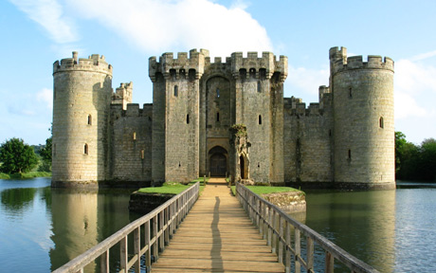](https://www.google.co.uk/url?sa=i&rct=j&q=&esrc=s&source=images&cd=&cad=rja&uact=8&ved=0ahUKEwjyxJryztbSAhVJJsAKHRgqDdkQjRwIBw&url=http://dreamicus.com/castle.html&psig=AFQjCNEoaEaIu_jl2KXAMkq7rsnBydUj0Q&ust=1489602225446758)[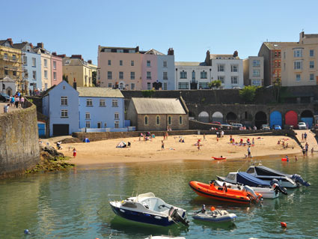](https://www.google.co.uk/url?sa=i&rct=j&q=&esrc=s&source=images&cd=&cad=rja&uact=8&ved=0ahUKEwi7kLquz9bSAhVBDMAKHbTkCMMQjRwIBw&url=https://www.welsh-cottages.co.uk/pembrokeshire/tenby&bvm=bv.149397726,d.ZGg&psig=AFQjCNGmDfLVwGZYWLwhIlD_Lp2x2waVvA&ust=1489602350516939)*If you are struggling for inspiration, use the photographs below for ideas:*

***Example 3: Describe a moment in your life when you felt frightened.***

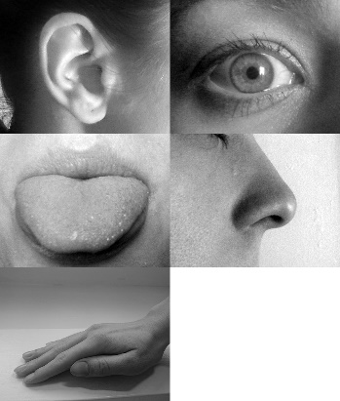*This question tests your ability to convey your feelings and describe the situation which made you feel frightened.*

**Using the senses**

**for effect**

*Good description tells us what impression the world would make on our senses. We need to consider how to convey to the reader our sense of sight, smell, sound, taste and touch.*

**TASK 8.** *Read the following passage which describes a sailor caught in a storm*. Highlight and label where the writer uses the following features:

**Sight**

*By midnight on the first night [the wind] had blown up. The barometer fell and the wind howled through the rigging. Changing sails on the foredeck was lethal. Kingfisher tried her best to cling to the water’s surface while I just tried to cling to her. I was being pounded, thrown again and again on to the deck as her hull flicked up to hit me while I was slammed down by the motion of falling from the wave before – it was unrelenting. With each impact I closed my eyes and gritted my teeth, hanging on as tightly as possible. I tried everything to calm her, but the waves were enormous, and whether we charged over them or fell down them, it was going to hurt.*

*Ellen MacArthur, ‘Taking on the World.’*

**Sound**

**Touch**

**Onomatopoeia**

**Personification**

**Repetition**

**TASK 9.** Now let’s develop some vocabulary and devices to describe your frightening moment. Fill in the blanks in the passage below, following the instructions in the brackets.

***This passage is about a boy who has lost his mum in a crowd.***

*__________________ (adverb) I was alone – I had lost my mum. It seemed like she had ________________ (verb) into thin air***,** *never to be seen again. The crowd ________________ (verb) me up like a _______________ (simile). My heart beat ____________ (adverb) and I began to ____________ (verb) like a ________________ (simile). _________________ (adverb) I shouted for ______ (noun) but none came. I gave up and _______ (verb) on the floor. It was hopeless. I was lost. Stunned, I ______________ (verb) at the pavement, wondering what to do. The crowds, who _________________ (verb) around me like fog on a winter’s afternoon, ignored me and carried on about their business.*

*“David,” _____________ (verb) a familiar voice, like a _____________________ ______________________ (simile). I wasn’t lost. My ordeal was over. Breathe.*

**TASK 10.** Describe a moment in your life when you felt frightened. Using the ideas and techniques you have developed, write your description below.

________________________________________________________________________________________________________________________________________________________________________________________________________________________________________________________________________________________________________________________________________________________________________________________________________________________________________________________________________________________________________________________________________________________________________________________________________________________________________________________________________________________________________________________________________________________________________________________________________________________________________________________________________________________________________________________________________________________________________________________________________________________________________________________________________________________________________________________________________________________________________________________________________________________________________________________________________________________________________________________________________________________________________________________________________________________________________________________________________________________________________________________________________________________________________________________________________________________________________________________________________________________________________________________________________________________________________________________________________________________________________________________________________________________________________________________________________________________________________________________________________________________________________________________________________________________________________________________________________________________________________________________________________________________________________________________________________________________________________________________________________________________________________________________________________________________________________________________________________________________________________________________________________________________________________________________________________________________________________________________________________________________________________________________________________________________________________________________________________________________________________________________________________________________________________________________________________________________________________________________________________________________________________________________________________________________________________________________________________________________________________________________________________________________________________________________________________________________________________________________________________________________________________________________________________________________________________________________________

Continue on a separate sheet.

**Commissioned by The PiXL Club Ltd.**

This resource is strictly for the use of member schools for as long as they remain members of The PiXL Club. It may not be copied, sold, or transferred to a third party or used by the school after membership ceases. Until such time it may be freely used within the member school.

All opinions and contributions are those of the authors. The contents of this resource are not connected with, or endorsed by, any other company, organisation or institution.

PiXL Club Ltd endeavour to trace and contact copyright owners. If there are any inadvertent omissions or errors in the acknowledgements or usage, this is unintended and PiXL will remedy these on written notification.