AO1 Secure Test

AO1: Read, understand and respond to texts

Students should be able to:
- Maintain a critical style and develop an informed personal response.
- Use textual references, including quotations, to support and illustrate interpretations.
We are going to test the following skills:
- Using a range of supporting examples from across the text
- Demonstrating an understanding of themes within the text
- Sustaining a response

TASK:
Select a practice exam question from the options below. Using the work you completed in the Secure Therapy tasks, complete a detailed plan, including pivotal moments, careful quotation selection and alternative interpretations. You may decide to write up the essay when you have finished.

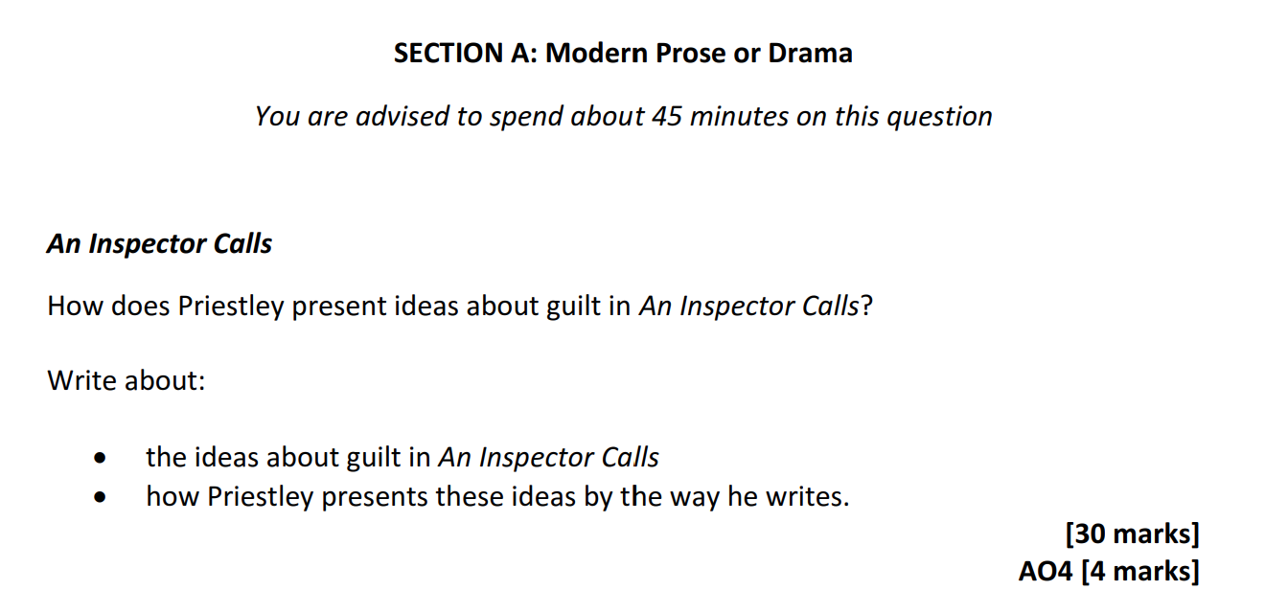
AQA options:

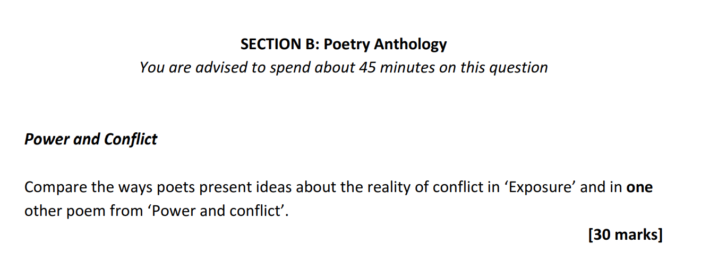

Edexcel options:

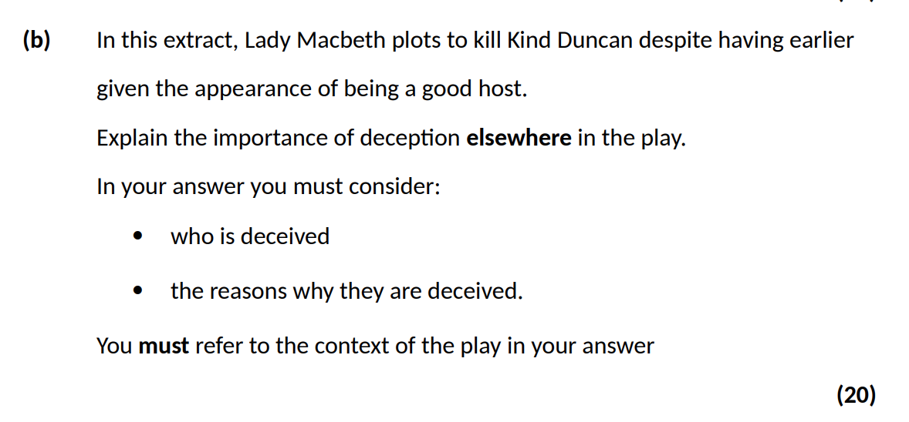


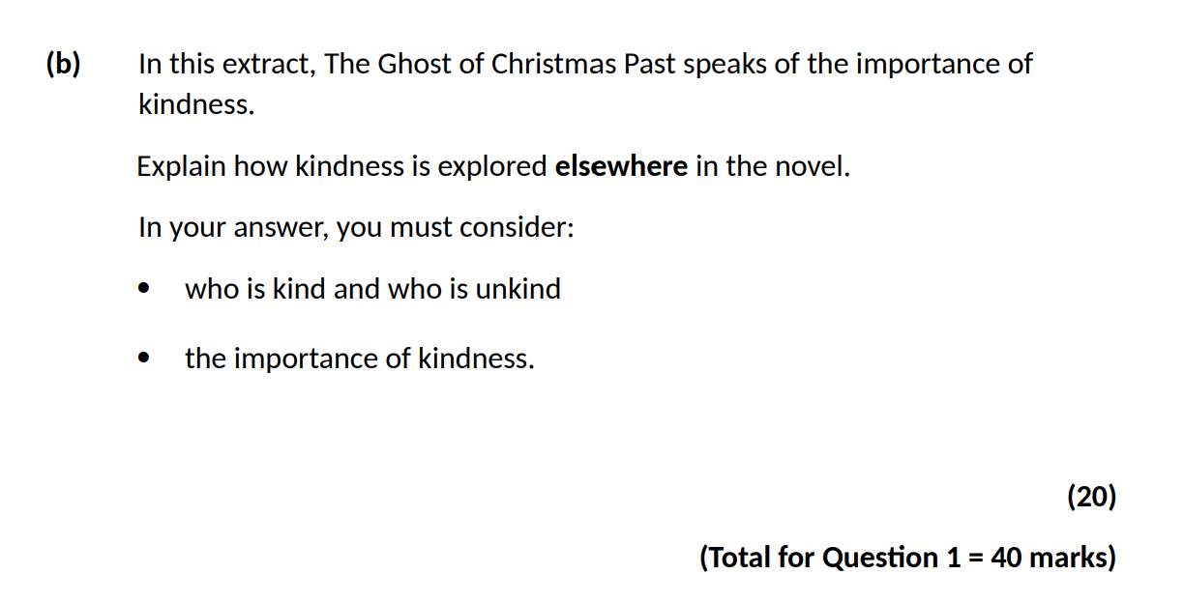

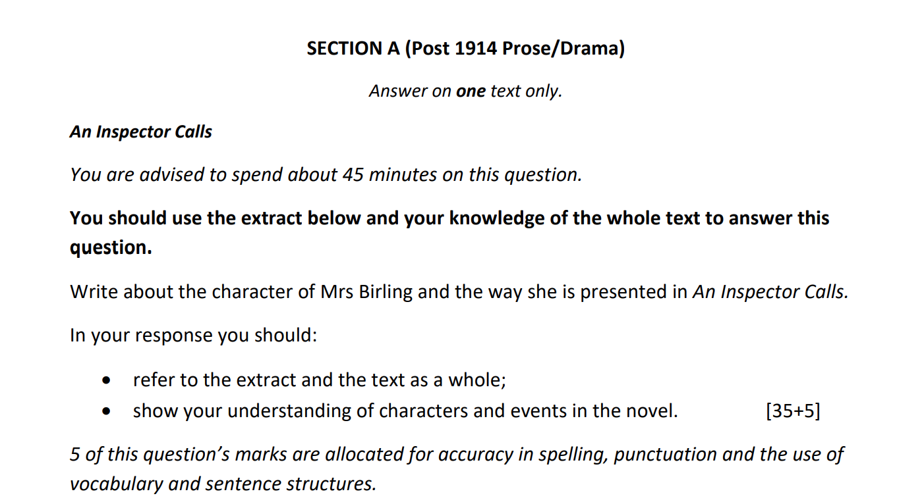
Eduqas option:

OCR option:
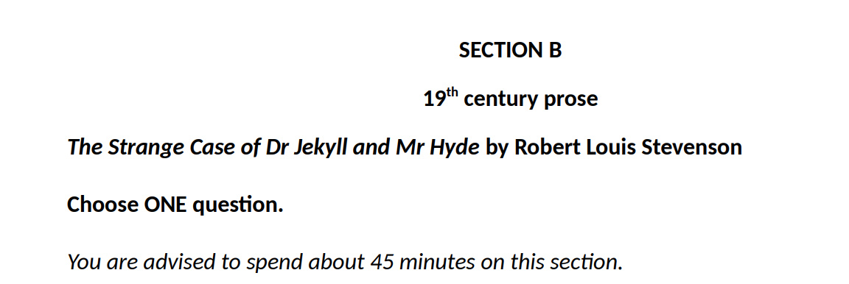

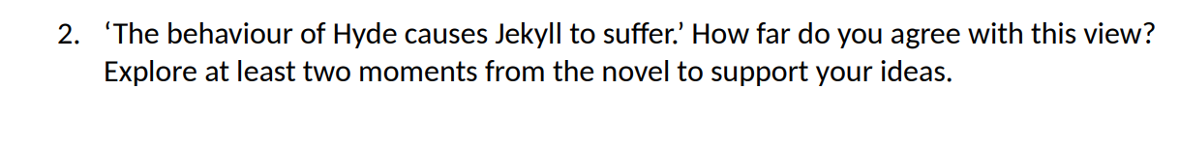

Introduction sentence or ‘thesis’: your overall argument and answer to the exam question.

Point 1:
Textual references:
Notes for explanation and context links if appropriate:

Point 2:
Textual references:
Notes for explanation and context links if appropriate:

Point 3:
Textual references:
Notes for explanation and context links if appropriate:

Conclusion sentence: sum up your overall argument

……………………………………………………………………………………………………………………………………………
…………………………………………………………………………………………………………………………………………………
…………………………………………………………………………………………………………………………………………………
…………………………………………………………………………………………………………………………………………………
…………………………………………………………………………………………………………………………………………………
…………………………………………………………………………………………………………………………………………………
…………………………………………………………………………………………………………………………………………………
…………………………………………………………………………………………………………………………………………………
…………………………………………………………………………………………………………………………………………………
…………………………………………………………………………………………………………………………………………………
…………………………………………………………………………………………………………………………………………………
…………………………………………………………………………………………………………………………………………………
…………………………………………………………………………………………………………………………………………………
…………………………………………………………………………………………………………………………………………………
…………………………………………………………………………………………………………………………………………………
…………………………………………………………………………………………………………………………………………………
…………………………………………………………………………………………………………………………………………………
…………………………………………………………………………………………………………………………………………………
…………………………………………………………………………………………………………………………………………………
…………………………………………………………………………………………………………………………………………………
…………………………………………………………………………………………………………………………………………………
…………………………………………………………………………………………………………………………………………………
…………………………………………………………………………………………………………………………………………………
…………………………………………………………………………………………………………………………………………………
…………………………………………………………………………………………………………………………………………………
…………………………………………………………………………………………………………………………………………………
…………………………………………………………………………………………………………………………………………………
…………………………………………………………………………………………………………………………………………………
…………………………………………………………………………………………………………………………………………………
…………………………………………………………………………………………………………………………………………………
…………………………………………………………………………………………………………………………………………………
…………………………………………………………………………………………………………………………………………………
…………………………………………………………………………………………………………………………………………………
…………………………………………………………………………………………………………………………………………………
…………………………………………………………………………………………………………………………………………………
…………………………………………………………………………………………………………………………………………………
…………………………………………………………………………………………………………………………………………………
…………………………………………………………………………………………………………………………………………………
…………………………………………………………………………………………………………………………………………………
…………………………………………………………………………………………………………………………………………………
…………………………………………………………………………………………………………………………………………………
…………………………………………………………………………………………………………………………………………………
…………………………………………………………………………………………………………………………………………………
…………………………………………………………………………………………………………………………………………………
…………………………………………………………………………………………………………………………………………………
…………………………………………………………………………………………………………………………………………………
…………………………………………………………………………………………………………………………………………………
…………………………………………………………………………………………………………………………………………………
…………………………………………………………………………………………………………………………………………………
…………………………………………………………………………………………………………………………………………………
…………………………………………………………………………………………………………………………………………………

Commissioned by The PiXL Club Ltd.

This resource is strictly for the use of member schools for as long as they remain members of The PiXL Club. It may not be copied, sold, nor transferred to a third party or used by the school after membership ceases. Until such time it may be freely used within the member school. All opinions and contributions are those of the authors. The contents of this resource are not connected with, nor endorsed by, any other company, organisation or institution. PiXL Club Ltd endeavour to trace and contact copyright owners. If there are any inadvertent omissions or errors in the acknowledgements or usage, this is unintended and PiXL will remedy these on written notification.

