AO1 Advanced Test

AO1: Read, understand and respond to texts

Students should be able to:
- Maintain a critical style and develop an informed personal response.
- Use textual references, including quotations, to support and illustrate interpretations.

We are going to test the following skills:
- Using sophisticated vocabulary to present a critical analysis
- Presenting a conceptualised response

TASK 1:
Select a practice exam question from the options below. Using the work you completed in the Advanced Therapy tasks, complete a thesis statement, plan and draft a response to the question. Highlight examples of academic vocabulary, sentence stems and evaluative adverbs when you have finished.

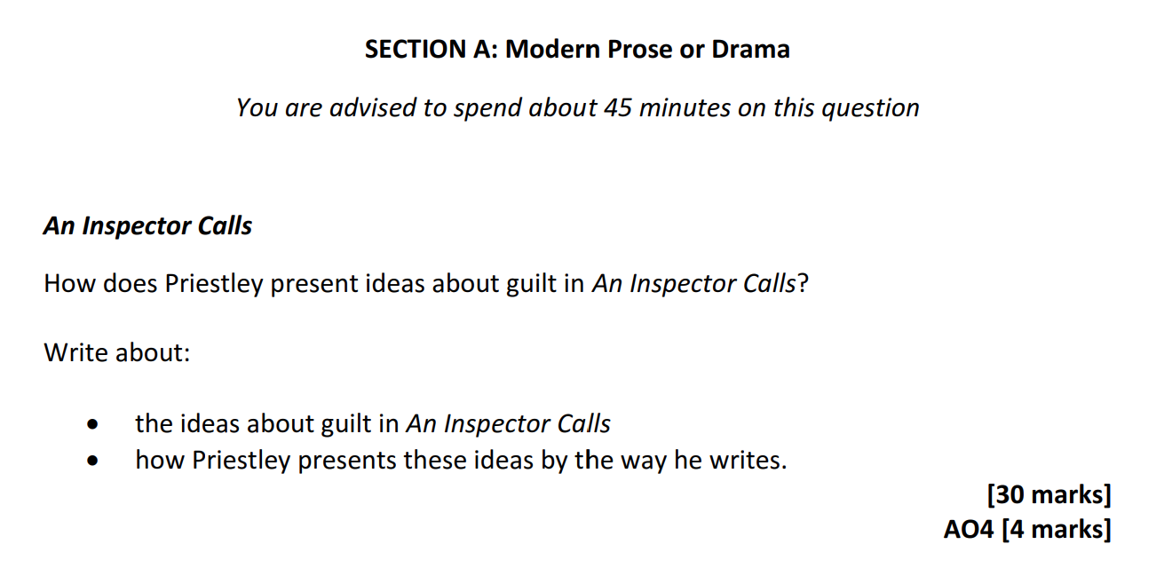
AQA options:

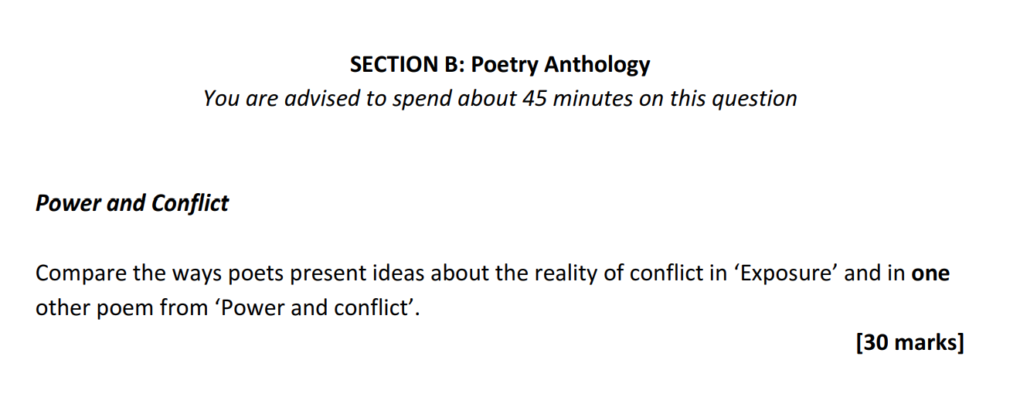

Edexcel options:

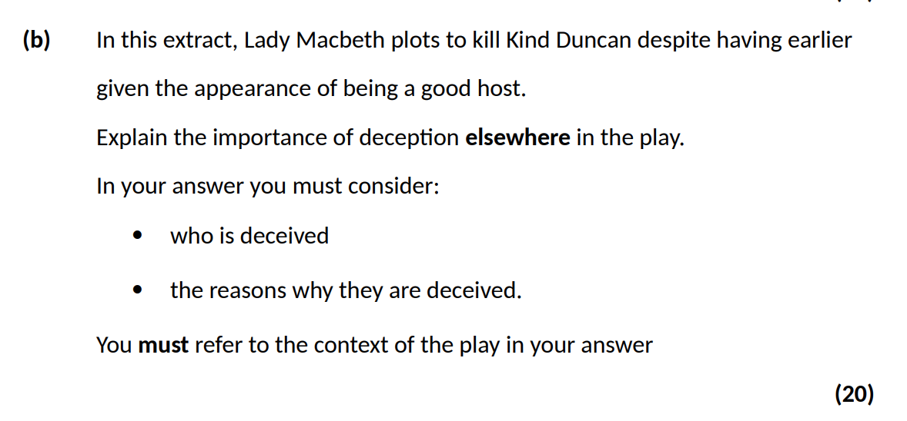


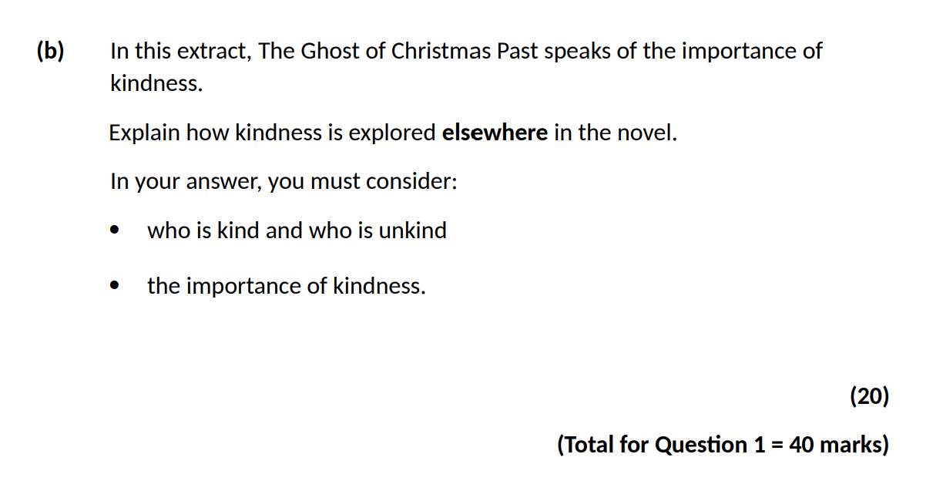

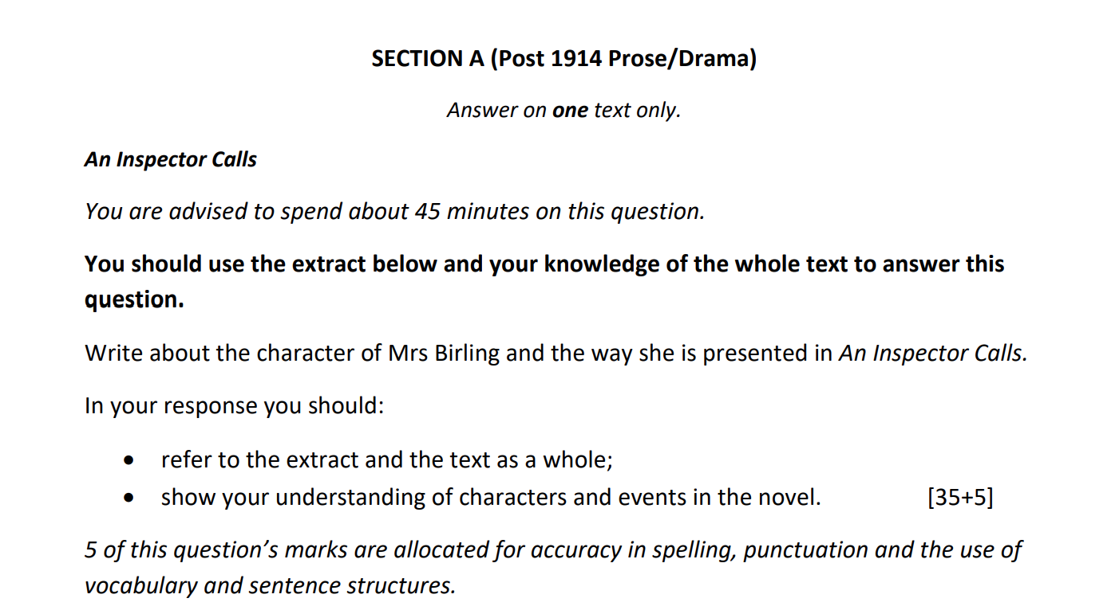
Eduqas option:

OCR option:
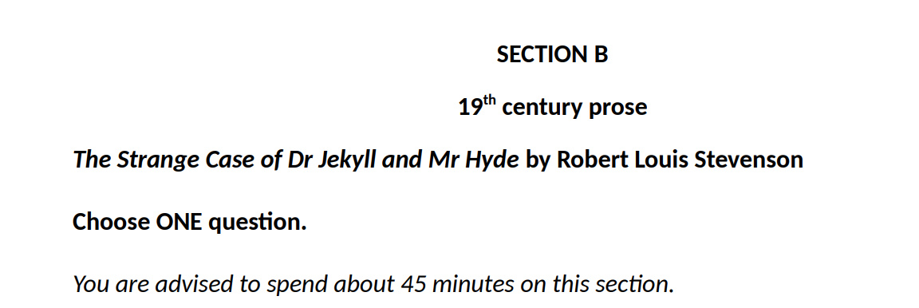

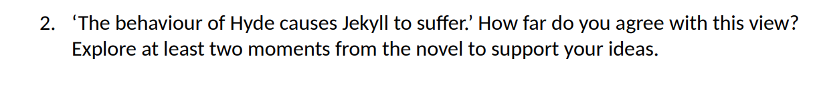

TASK 2:
Ask your teacher for a top-level GCSE Literature response. They may give you an exam board exemplar of a piece of work from someone else in your year group.

- Read the exemplar and highlight any vocabulary that you believe sounds academic or sophisticated. You may want to use a dictionary, thesaurus and Geoff Barton’s “100 words…” from Advanced Therapy Task 1.
- Try to recreate the student’s plan for this answer using the Venn diagram model from Advanced Therapy Task 3. Break the answer down into its individual parts.
- Make a list of features that you would like to include in your answers from now on. Let this student be your role model.
- Now improve your own answer from Task 1 using the exemplar.

…………………………………………………………………………………………………………………………………………………
…………………………………………………………………………………………………………………………………………………
…………………………………………………………………………………………………………………………………………………
…………………………………………………………………………………………………………………………………………………
…………………………………………………………………………………………………………………………………………………
…………………………………………………………………………………………………………………………………………………
…………………………………………………………………………………………………………………………………………………
…………………………………………………………………………………………………………………………………………………
…………………………………………………………………………………………………………………………………………………
…………………………………………………………………………………………………………………………………………………
…………………………………………………………………………………………………………………………………………………
…………………………………………………………………………………………………………………………………………………
…………………………………………………………………………………………………………………………………………………
…………………………………………………………………………………………………………………………………………………
…………………………………………………………………………………………………………………………………………………
…………………………………………………………………………………………………………………………………………………
…………………………………………………………………………………………………………………………………………………
…………………………………………………………………………………………………………………………………………………
…………………………………………………………………………………………………………………………………………………
…………………………………………………………………………………………………………………………………………………
…………………………………………………………………………………………………………………………………………………
…………………………………………………………………………………………………………………………………………………
…………………………………………………………………………………………………………………………………………………
…………………………………………………………………………………………………………………………………………………
…………………………………………………………………………………………………………………………………………………
…………………………………………………………………………………………………………………………………………………
…………………………………………………………………………………………………………………………………………………
…………………………………………………………………………………………………………………………………………………
…………………………………………………………………………………………………………………………………………………
…………………………………………………………………………………………………………………………………………………
…………………………………………………………………………………………………………………………………………………
…………………………………………………………………………………………………………………………………………………
…………………………………………………………………………………………………………………………………………………
…………………………………………………………………………………………………………………………………………………
…………………………………………………………………………………………………………………………………………………
…………………………………………………………………………………………………………………………………………………
…………………………………………………………………………………………………………………………………………………
…………………………………………………………………………………………………………………………………………………
…………………………………………………………………………………………………………………………………………………
…………………………………………………………………………………………………………………………………………………
…………………………………………………………………………………………………………………………………………………
…………………………………………………………………………………………………………………………………………………
…………………………………………………………………………………………………………………………………………………
…………………………………………………………………………………………………………………………………………………
…………………………………………………………………………………………………………………………………………………
…………………………………………………………………………………………………………………………………………………
…………………………………………………………………………………………………………………………………………………
…………………………………………………………………………………………………………………………………………………
…………………………………………………………………………………………………………………………………………………
…………………………………………………………………………………………………………………………………………………
…………………………………………………………………………………………………………………………………………………
…………………………………………………………………………………………………………………………………………………
…………………………………………………………………………………………………………………………………………………
…………………………………………………………………………………………………………………………………………………
…………………………………………………………………………………………………………………………………………………
…………………………………………………………………………………………………………………………………………………
…………………………………………………………………………………………………………………………………………………
…………………………………………………………………………………………………………………………………………………
…………………………………………………………………………………………………………………………………………………
…………………………………………………………………………………………………………………………………………………
…………………………………………………………………………………………………………………………………………………
…………………………………………………………………………………………………………………………………………………
…………………………………………………………………………………………………………………………………………………
…………………………………………………………………………………………………………………………………………………
…………………………………………………………………………………………………………………………………………………
…………………………………………………………………………………………………………………………………………………
…………………………………………………………………………………………………………………………………………………
…………………………………………………………………………………………………………………………………………………
…………………………………………………………………………………………………………………………………………………
…………………………………………………………………………………………………………………………………………………
…………………………………………………………………………………………………………………………………………………
…………………………………………………………………………………………………………………………………………………
…………………………………………………………………………………………………………………………………………………
…………………………………………………………………………………………………………………………………………………
…………………………………………………………………………………………………………………………………………………
…………………………………………………………………………………………………………………………………………………
…………………………………………………………………………………………………………………………………………………
…………………………………………………………………………………………………………………………………………………
…………………………………………………………………………………………………………………………………………………
…………………………………………………………………………………………………………………………………………………
…………………………………………………………………………………………………………………………………………………

Commissioned by The PiXL Club Ltd.

This resource is strictly for the use of member schools for as long as they remain members of The PiXL Club. It may not be copied, sold, nor transferred to a third party or used by the school after membership ceases. Until such time it may be freely used within the member school. All opinions and contributions are those of the authors. The contents of this resource are not connected with, nor endorsed by, any other company, organisation or institution. PiXL Club Ltd endeavour to trace and contact copyright owners. If there are any inadvertent omissions or errors in the acknowledgements or usage, this is unintended and PiXL will remedy these on written notification.

