PEARSON EDEXCEL BTEC LEVEL 3 EXTENDED CERTIFICATE IN SPORT (360 GLH)

Bridging Unit 2020

Contacts:

Head of Physical Education – Mr Longmore
clongmore@tuxford-ac.org.uk

Teacher of Physical Education – Mrs Crashley
vcrashley@tuxford-ac.org.uk

Teacher of Physical Education – Mr Thompson
sthompson@tuxford-ac.org.uk

Teacher of Physical Education – Mrs Rafferty
krafferty@tuxford-ac.org.uk

Introduction

This series of tasks and activities are designed to give you an insight into the Pearson EDEXCEL BTEC Level 3 Extended Certificate in Sport course. As part of the transition from year 11 Level 1/2 BTEC Sport to Level 3 BTEC Sport it is important to develop a greater understanding of certain aspects of the course which will help you over the next two years. Please complete the following booklet.
If you did not study a sports course in years 10 and 11 do not worry! A percentage of the topics we will cover, haven’t been studied in GCSE PE or BTEC Sport so the information will be new to all students. It is however essential you are aware of the step up from key stage 4.
Name

School

Do you play sport?

If yes to the question above;
Team & League/Competitions

Other commitments e.g. part time jobs/gym membership

This booklet has been prepared by the PE faculty for you to read and the work contained in it will ensure that you get off to a positive start in this subject area. It is very important that you read this booklet carefully over the summer and attempt to complete the work to the best of your ability and submit it to your teacher. This will be the first impression you create and is a real indicator of how seriously you are prepared to be in your studies.

COURSE OUTLINE

Eligibility for awards;

In ordered to awarded a qualification a learner must complete all units and achieve a pass or above in all mandatory units.

To achieve any qualifications grade, learners must;
1. Complete and have an outcome (D, M P and U) for all units with a valid combination.

2. Achieve the required units at pass or above and for the Extended Certificate achieve a minimum of 360 GLH at a pass or above.
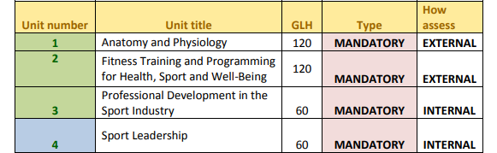

Points available for internal & external units
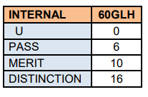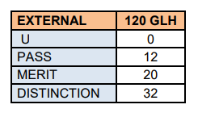

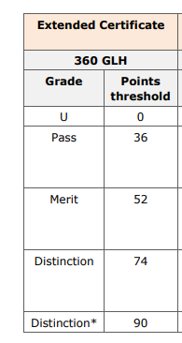

PEARSON EDEXCEL LEVEL 3 EXTENDED CERTIFICATE IN SPORT
At a Glance

Course Details

Course Title: BTEC National in Sport Level 3

Exam board: Edexcel/Pearson

Exam Board web site:
www.edexcel.com
www.btec.co.uk

Assessment method: The BTEC Sport Level 3 qualification is assessed both externally and internally via coursework based assignments.

The pathway you will study at Tuxford is the Extended Certificate which is equivalent to an A Level qualification.

Unit 1 - Anatomy and Physiology: is a written exam for 1.5 hours, worth 90 marks. This will be set and marked by Pearson, with 1 re-take allowed.

Unit 2 - Fitness Training and Programming for Health, Sport and well-being: is the second externally assessed unit where pre-released information is released 1 week prior to a controlled assessment in exam conditions. 1 week prior to the assessment learners will receive information within controlled conditions where 4 hours can be spent preparing information. After this, on a date specified by Pearson, learners will then spend a further 2.5 hours applying this within controlled exam conditions.

About the course

There has been significant increases in the popularity of BTEC Sport Level 3 since 2010. This has been driven by increased investment, publicity (Olympics), and subsequent vocational opportunities. With a third of workers in this sector having no formal qualifications beyond Level 1, many employers complain they cannot fill vacancies because of the skills shortage. This course exists to enable learners to be at the forefront of sport where these opportunities exist. Units are tailored to the needs of learners and the Sports sector (e.g. Sports Coaching).

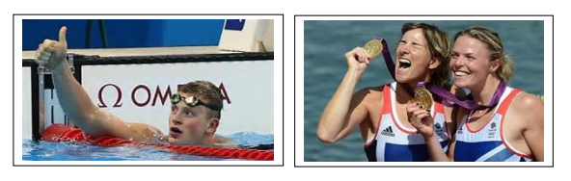

ASSESSMENT POLICY
External assessment (Unit 1 Anatomy & Physiology & Unit 2 Fitness Training & Programming):

Each external assessment for BTEC National is linked to specific units. All of the units are developed for external assessment of 120GLH to allow learners to demonstrate breadth and depth of achievement. Each assessment is taken under specified conditions, then marked by Pearson and a grade is awarded. Learners must achieve all external units at pass grade or above. The styles of external assessment used for qualification in the sport suite are:

Examinations (Unit 1 Anatomy & Physiology) - all learners take the same assessment at the same time, normally with a written outcome.
Set tasks (Unit 2 Fitness Training & Programming) – learners take the assessment during the defined window and demonstrate understanding through completion of a vocational task. Some external assessments include a period of preparation using set information.

External assessments are available once or twice a year and learners can only have one resit attempt during the programme.

Internal assessment (Unit 3 Professional Development in the Sports Industry & Unit 4 Sports Leadership):

Each student is allowed ONE submission for each assignment. Therefore, it is crucial that you get it right first time and meet the required assessment criteria. You should make sure that you fully understand the assignment or assessment task that you have been issued. Don’t be afraid to ask your unit teachers for help if you don’t understand what you need.
So what happens if I don’t achieve the assessment criteria after my submission?

Due to every assignment contributing towards the final grade, you may be entitled to one opportunity for a resubmission to meet the assessment criteria. However, this has to be authorised by the Lead Internal Verifier and you must meet the following criteria:

- You met the initial deadline set for the assignment.
- Your teacher feels you can improve your evidence with no further guidance.
- You have signed and dated a declaration of authenticity for your assignment.

If these three conditions have not been met, you will not be authorised for a resubmission.
Should you be authorised for a resubmission, you will have 10 working days to complete the assignment from the date of receiving your feedback. You will not be given any additional guidance from your unit teacher. Get it right first time. Be prepared for your assignments!

What happens if my resubmission still doesn’t meet the pass criteria?
The qualification doesn’t allow for compensation, therefore students are required to pass every unit in order to gain the full qualification.
UNIT 1 - ANATOMY & PHYSIOLOGY

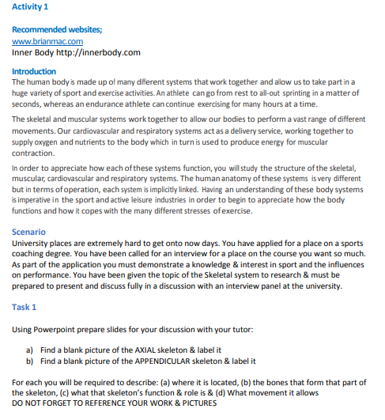

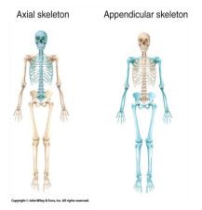
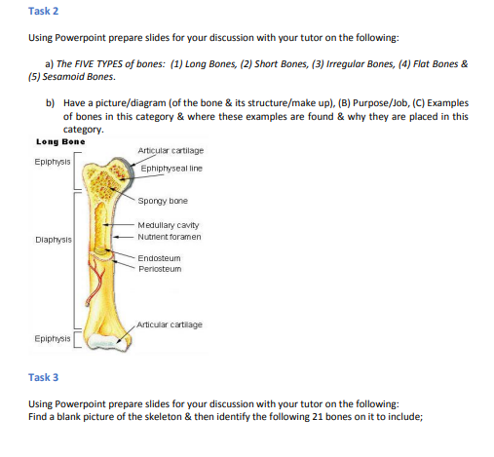
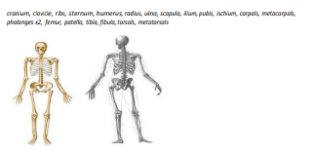

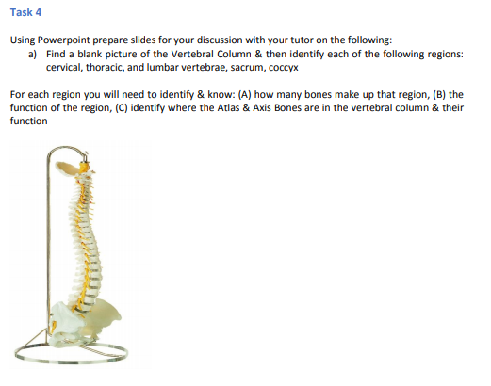

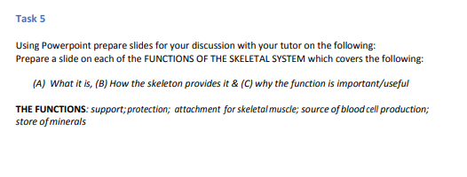

UNIT 2 – FITNESS TRAINING & PROGRAMMING FOR HEALTH, SPORT & WELL-BEING

Positive & Negative Lifestyle Factors
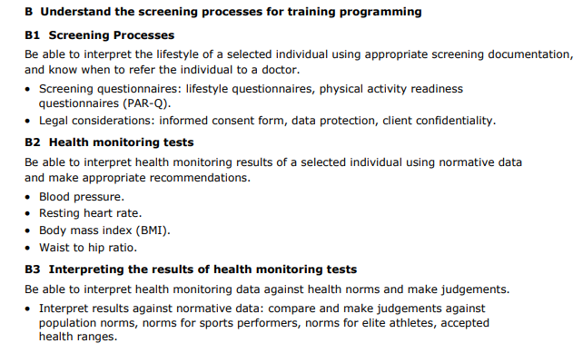

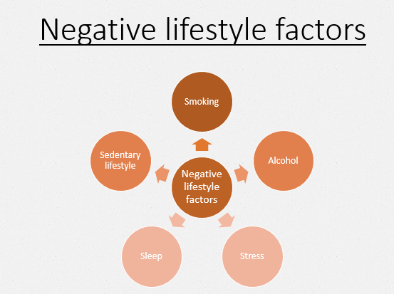
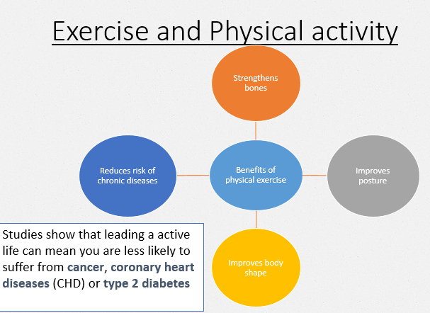

Task 1
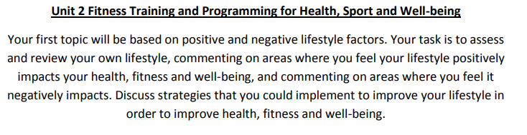
Use the information from the course specification to help you consider your own lifestyle.
Produce an A4 page which summaries the key information making links to all negative and positive lifestyle factors.

Task 2

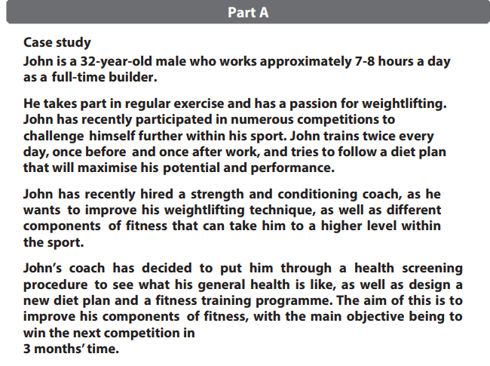

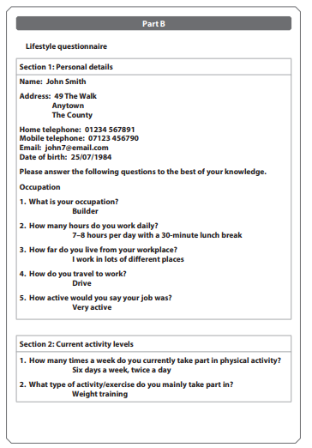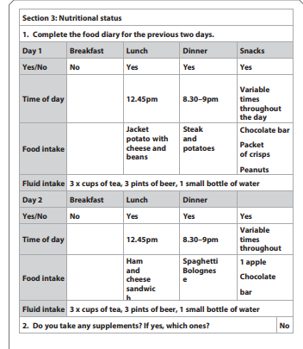
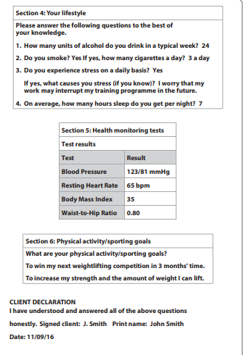

The following question would be worth 12 marks in the exam.
Use the exemplar material from Mr Mann on the following pages to support you.
Interpret the lifestyle factors and screening information for John Smith.

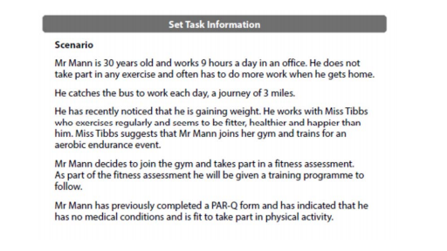
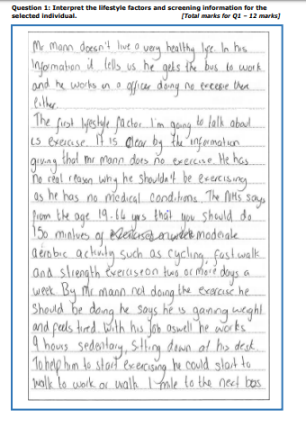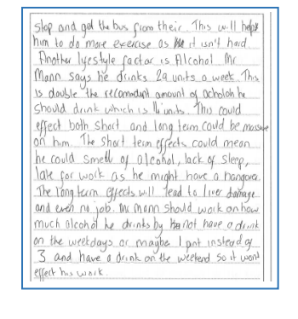

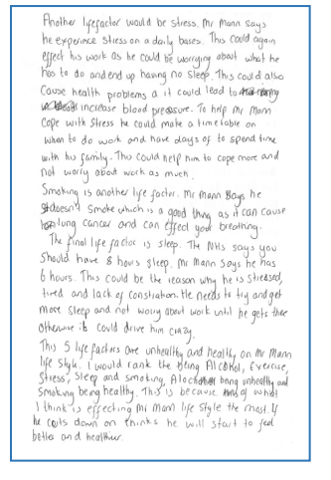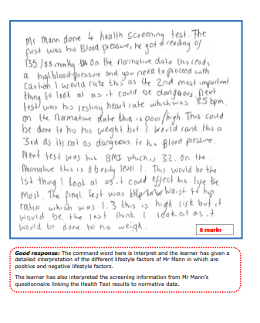

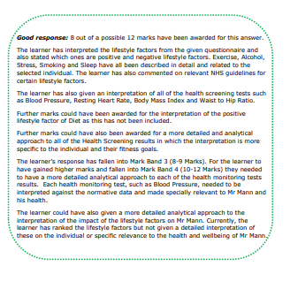
UNIT 3 - PROFESSIONAL DEVELOPMENT IN THE SPORTS INDUSTRY

Activity 1 – Size of the Sports Industry
Linked to Unit 3 – Working in the Sports Industry

Scenario - Imagine you are researcher for the different career opportunities in the sports industry.
We need you to: Review the size of the sports industry nationally, in the East Midlands and in Retford/Newark. Your research should cover the following topics from the specification:
The size, breadth and geographic spread of the sports industry, locally and nationally and factors that affect sports provision and employment opportunities.
- Sport and recreation industry data, economic significance, number of jobs.
- Geographical factors – location, environment, infrastructure, population.
- Socio-economic factors – wealth, employment, history, culture, fashion and trend.
- Season factors, e.g. swimming pools that only open in the summer, summer camps, holiday sports clubs, competition seasons, training camps.
Success criteria is based on:
Pass - Identify the size of the sports industry nationally, regionally and locally
Merit - Identify the size of the sports industry nationally, regionally and locally referring to research sources and multiple job roles within the sector.
Distinction - Identify the size of the sports industry nationally, regionally and locally referring to research sources and multiple job roles within the sector. Evaluate the impact of Geographical, Socio-economic and Seasonal factors on the size of the sports industry in local areas.
Complete the work in an essay type format using the example on the following pages;

Lifeguard Coach Personal Trainer
Key tips:
Use the exemplar work on the following pages to help you.

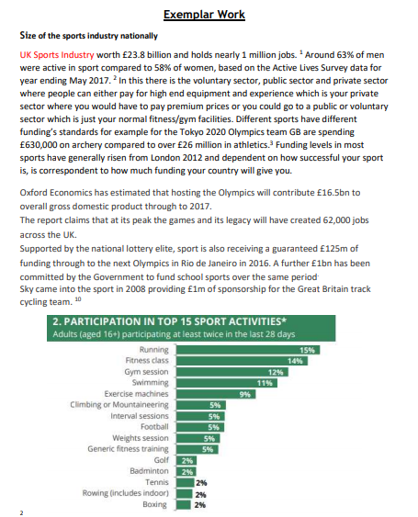

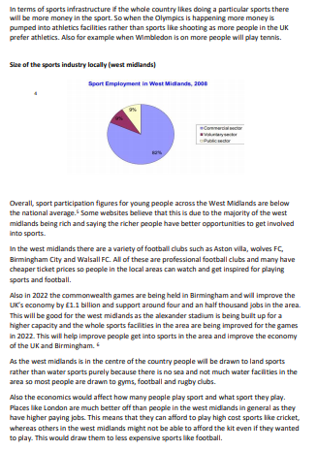

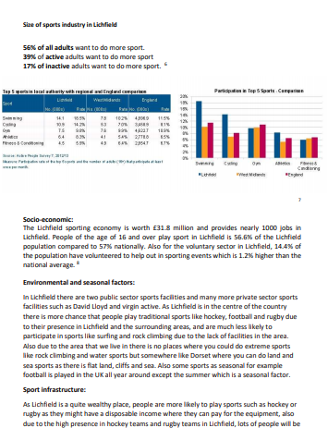
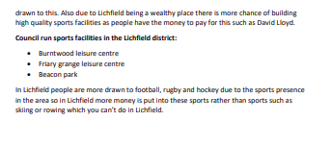

UNIT 4 SPORTS LEADERSHIP
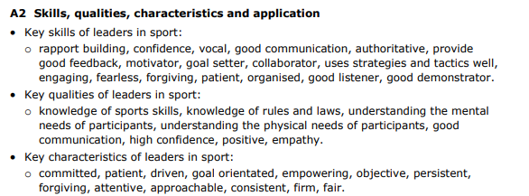

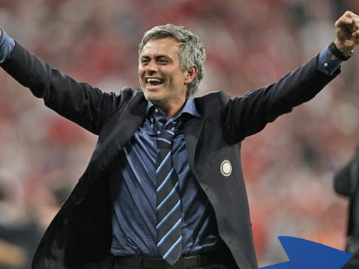

Answer the questions below in as much detail as possible using suitable examples;

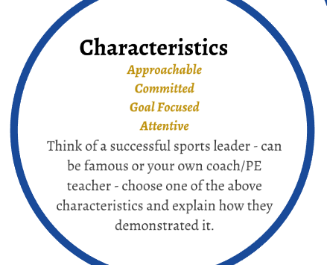

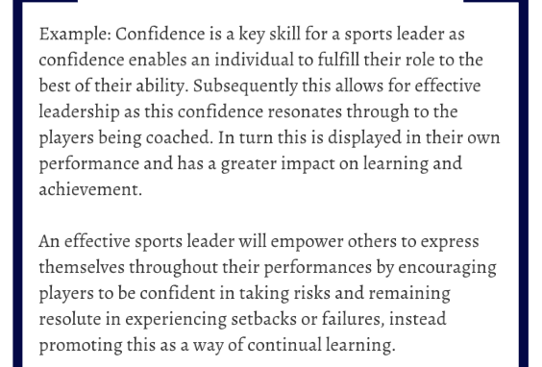
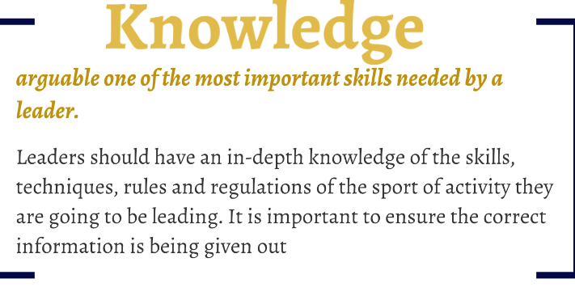

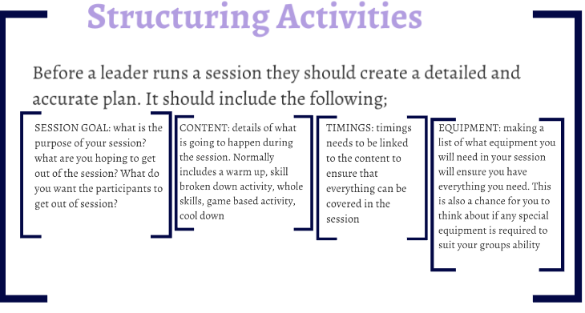

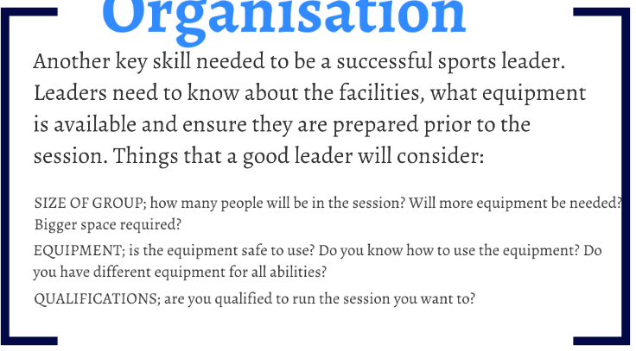

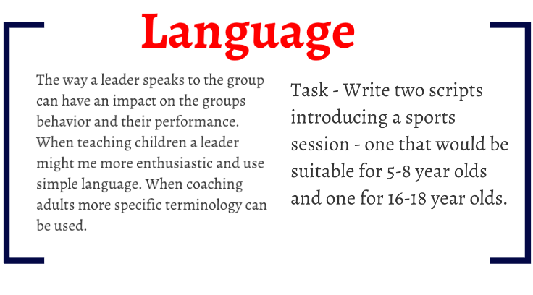
Practice Assignment Task
Qualification |  | Pearson BTEC Level 3 National Extended Certificate in Sport
Unit number and title |  | Unit 4: Sports Leadership
Learning aim(s) (For NQF only) |  | A: Understand the roles, qualities and characteristics of an effective sports leader
Assessor |  | The Physical Education Faculty
Issue date |  | May 2020
Hand in deadline |  | September 2020
Vocational Scenario or Context |  | You have been representing East Markham Sports Club from a number of years in a variety of sports. You are the most experienced member of the club and a role model to younger members. A number of local authorities have contacted you regarding leadership opportunities in the local area. In order to apply for the role you should produce a written essay showing your understanding of the skills, qualities and characteristics required to be successful leader. Use examples of managers, coaches, teachers to support your written statements.
Task 1 |  | Part 1  Split your assignment up into three clear sections. The sections should be the leadership roles that you have selected to write about.  - Skills should include: Rapport building, confidence, vocal, good communication, authoritative, provide good feedback, motivator, goal setter, collaborator, uses strategies and tactics well, engaging, fearless, forgiving, patient, organised, good listener, good demonstrator.  - Qualities should include: Knowledge of sports skills, knowledge of rules and laws, understanding the mental needs of participants, understanding the physical needs of participants, good communication, high confidence, positive, empathy.  - Key characteristics should include: Committed, patient, driven, goal orientated, empowering, objective, persistent, forgiving, attentive, approachable, consistent, firm, and fair.  Part 2  - Your essay must discuss, explain analyse and evaluate the application of skills, qualities and characteristics in different roles and provide real life examples of the effective use of the skills, qualities and characteristics of your three selected leaders
Criteria covered by this task:
Unit/Criteria reference | To achieve the criteria you must show that you are able to:
A.P1 | Discuss the skills, qualities and characteristics of three different leadership roles within different sport and exercise activities or environments.
A.P2 | Explain the importance of skills, qualities and characteristics in the leadership role within different sport and exercise activities or environments.
A.M1 | Analyse the importance of skills, qualities and characteristics in the leadership role within different sport and exercise activities or environments.
A.D1 | Evaluate the impact of skills, qualities, characteristics on sports leadership within different sport and exercise activities or environments.

LISTEN, WATCH, READ, STUDY
Highlight the tasks as you complete them

Complete this MOOC.  Football: more than a game  University of Edinburgh  This course is open now! | Listen to this radio programme from the BBC World service. Sports Hour is a live Saturday morning sports show with reports, debate and humour. There are over 280 shows available covering all world sport.  BBC World Service: Sports hour  BBC Programmes | Read this article which explores the science behind wearing a helmet in sporting activities and how helmets are there to stop brain fracture and not concussion.  Football helmets don't protect against concussion - and we're not sure what does  Ideas TED | Watch this TED talk  which explores how racial stereotypes have infiltrated the language we use to discuss athletes.  Shouldn’t sports be colour-blind  TED Talks – Patrick Ferrucci | Complete this course.  Exercise prescription for the prevention and treatment of disease  Future Learn  Available now or 4th May 2020
Listen to this radio programme.  This is a daily podcast bringing you the latest from the Premier League, EFL, European football and more.  BBC Radio 5 Live  BBC Programmes | Read this article  which explores some of the key gender issues in sports.  Sports are designed around men – and that needs to change  Ideas TED | Watch this TED talk.  Are athletes really getting faster, better, stronger?  TED Talks – David Epstein | Listen to this podcast in which Calum and Buncey react to KSI's split-decision victory over Logan Paul in Los Angeles.  KSI vs Logan Paul II  BBC Sounds | Watch this TED talk.  My 12 pairs of legs  TED Talks – Aimee Mullins
Watch this TED talk in which Valorie Kondos Field, long-time coach of the UCLA women's gymnastics team, shares the secret to her success. Hint: it has nothing to do with "winning."  Why Winning doesn’t always equal success  TED Talk – Valorie Kondos | Watch this TED talk in which Christopher McDougall explores the mysteries of the human desire to run.  Are we born to run?  TED Talk – Christopher McDougall | Watch this TED talk. How much do you know about intellectual disabilities?  Special Olympics let me be myself – a champion  TED Talk – Matthews Williams | Watch this TED talk.  Amazing, inspiring feats of daring and determination that will bring you everywhere from the high skies to the deep sea. (Playlist of eight talks).  Extreme sports  TED Talks | Listen to this podcast from the British Journal of Sports Medicine. It covers all sorts of aspects of Sports Medicine, from the science behind running shoes to the power of sleep.  BJSM Podcast  Also available on other podcast providers – search ‘BJSM’

READING LIST

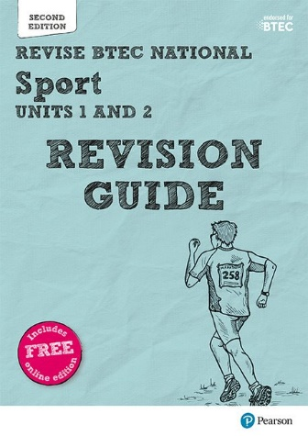
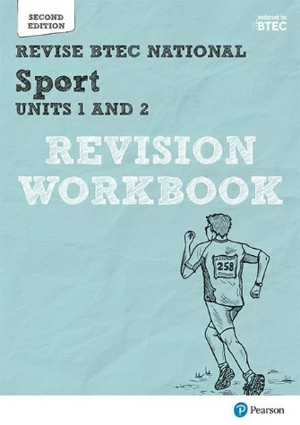
Please purchase the revision workbook and revision guide through the Pearson website.
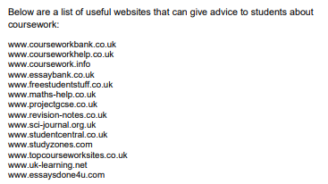

KEY TERMS FOR ASSIGNMENTS & EXAMS
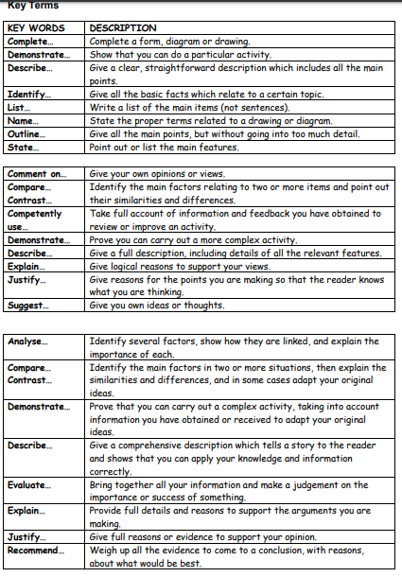

FACULTY EXPECTATIONS
There are some expectations that we set for all students who are studying BTEC Sport Level 3.
Students are to provide a notepad, pens, pencils and a folder for their lessons, a folder for each unit of the course (4 in total).
It is recommended that a USB storage device (memory stick) is also provided to transfer work to and from the school/home computers.
It is expected that students attend all lessons promptly and in the correct business attire. If a student misses a lesson it is expected that they will speak to the member of staff who taught the lesson and catch up with the work.
When students are involved in practical lessons they will be expected to wear appropriate kit and clothing.
Mobile phones are not to be used in lessons and must be switched off.
Students will be provided with homework and coursework to be completed at home or in study time at school. It is expected that all students will hand their work in for marking promptly and to the best of their ability.
The workload is considerable and approximately six hours per week should be completed at home as independent research/study.
In addition to lessons the PE Faculty endeavours to hold regular support sessions after school allowing students to complete work with extra guidance available.
We hope you manage to stay safe and remain active over the lockdown period and the summer holidays. We look forward to welcoming you in September 2020.
Tuxford Academy PE Faculty

