OCR A LEVEL (H555)
PHYSICAL EDUCATION

Bridging Unit 2020

Contacts:

Head of Physical Education – Mr Longmore
clongmore@tuxford-ac.org.uk

Curriculum Leader – Miss Aisthorpe
saisthorpe@tuxford-ac.org.uk

Teacher of Physical Education – Mr Bingham
lbingham@tuxford-ac.og.uk

Introduction

This series of tasks and activities are designed to give you an insight into OCR A-Level Physical Education. As part of the transition from year 11 AQA GCSE PE to OCR A-Level PE it is important to develop a greater understanding of certain aspects of the course which will help you over the next two years. Please complete the following booklet.
If you did not study GCSE PE in years 10 and 11 do not worry! A high percentage of the topics we will cover, haven’t been studied at GCSE so the information will be new to all students. It is however essential you are aware of the step up from key stage 4.
Name

School

Sport

Team & League

Training Days & Times

Throughout the next two years of study you will be encouraged to enhance your involvement in sport and develop yourself as a performer or coach. It is therefore a prerequisite of the course that you are currently involved in competitive sport or have been and intend to return to competition in the near future. Even if you are injured you can keep a record of your treatment and rehabilitation which is an inevitable occurrence in a performer’s development.

Over the two years you will study the following units of work;

Component 01: Physiological factors affecting performance (90 marks – 2 hour exam paper)
1.1 Applied anatomy and physiology
1.2 Exercise physiology
1.3 Biomechanics.

Component 02: Psychological factors affecting performance (60 marks – 1 hour exam paper)
2.1 Skill acquisition
2.2 Sports psychology.

Component 03: Socio-cultural issues in physical activity and sport (60 marks – 1 hour exam paper)
3.1 Sport and Society
3.2 Contemporary issues in physical activity and sport

Component 04: Performance in physical education (NEA)
4.1 Performance or coaching of an activity taken from the approved lists*.

OCR A LEVEL PE
At a Glance

Aims and learning outcomes

OCR’s A Level in Physical Education will equip learners with both a depth and breadth of knowledge, understanding and skills relating to scientific, socio-cultural and practical aspects of physical education.

This requires them to:
• develop theoretical knowledge and understanding of the factors that underpin physical activity and sport and use this knowledge to improve performance

• understand how physiological and psychological states affect performance

• understand the key socio-cultural factors that influence people’s involvement in physical activity and sport

• understand the role of technology in physical activity and sport
• refine their ability to perform effectively in physical activity and sport by developing skills and techniques and selecting and using tactics, strategies and/or compositional ideas
• develop their ability to analyse and evaluate to improve performance
• understand the contribution which physical activity makes to health and fitness
• improve as effective and independent learners and as critical and reflective thinkers with curious and enquiring minds.
For the full specification please visit http://www.ocr.org.uk/Images/234833-specificationaccredited-a-level-gce-physical-education-h555.pdf

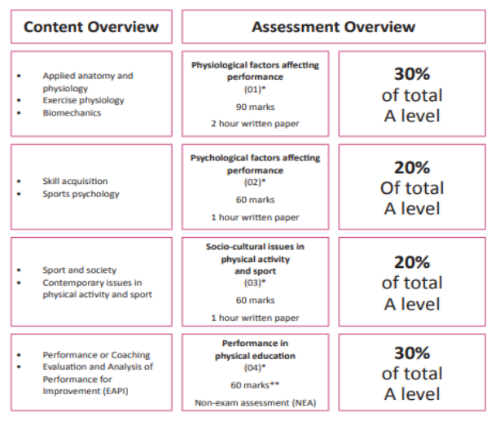
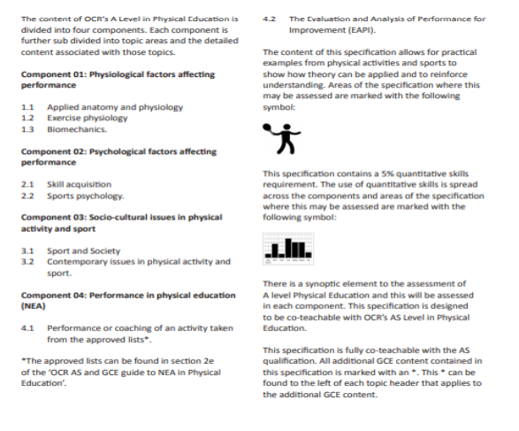
APPLIED ANATOMY & PHYSIOLOGY
Please complete definitions for the following key terms:
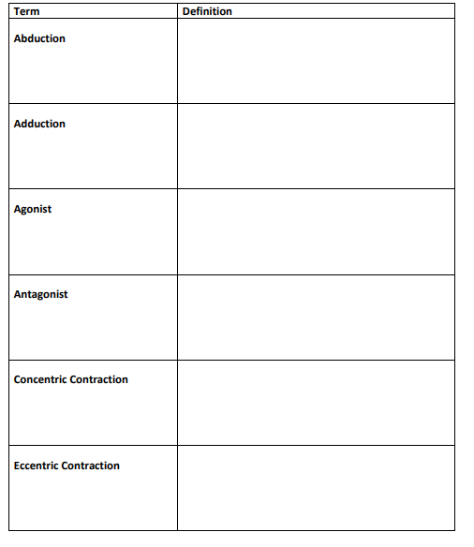

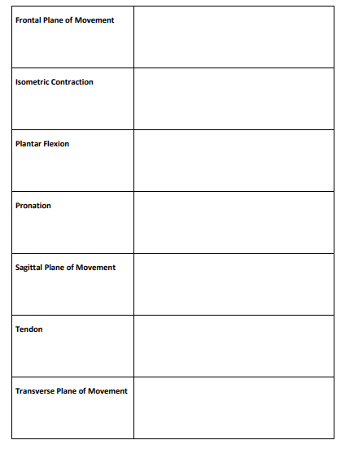

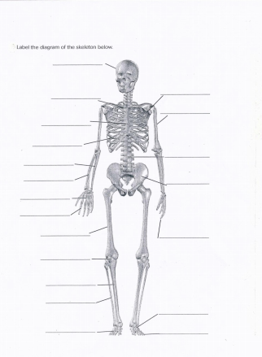

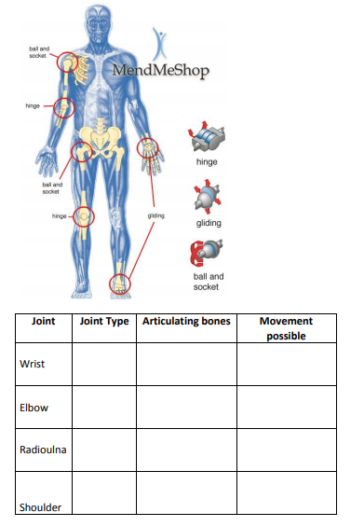
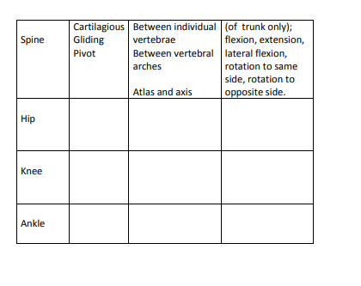

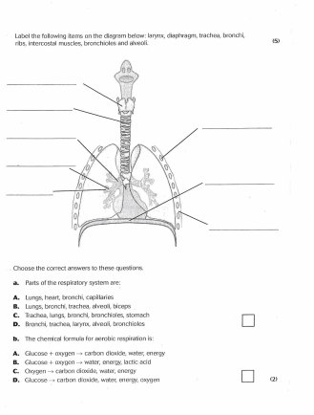

EXERCISE PHYSIOLOGY
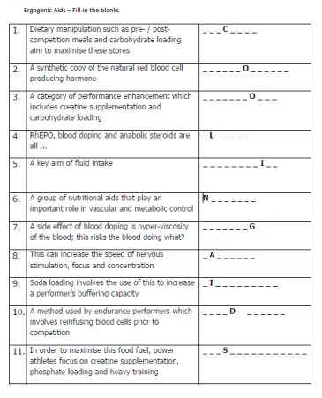

BIOMECHANICS

SKILL ACQUSITION

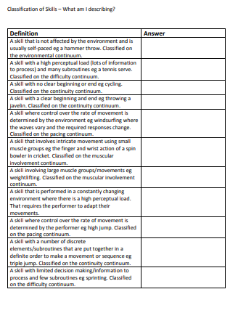
Task
Select a skill from the sport you intend to be assessed in and produce a written statement about that skill and how it links to the various classifications listed above.

SPORT PSYCHOLOGY
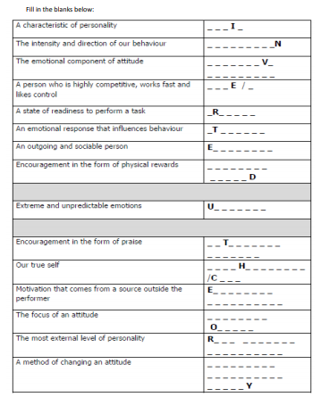
Tasks
1) Research and find out information about the following leadership styles;
- autrocratic
- democratic
- laissez faire
2) Using your knowledge of positive thinking, self-talk, mental rehearsal, imagery and goal setting describe how they can be used to manage stress in sport.
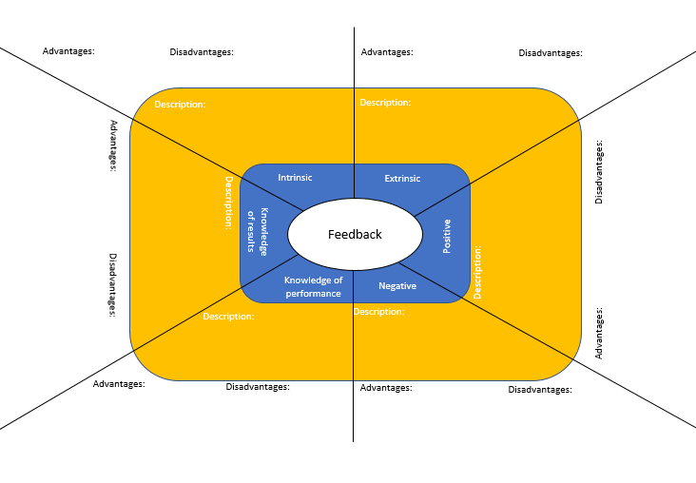

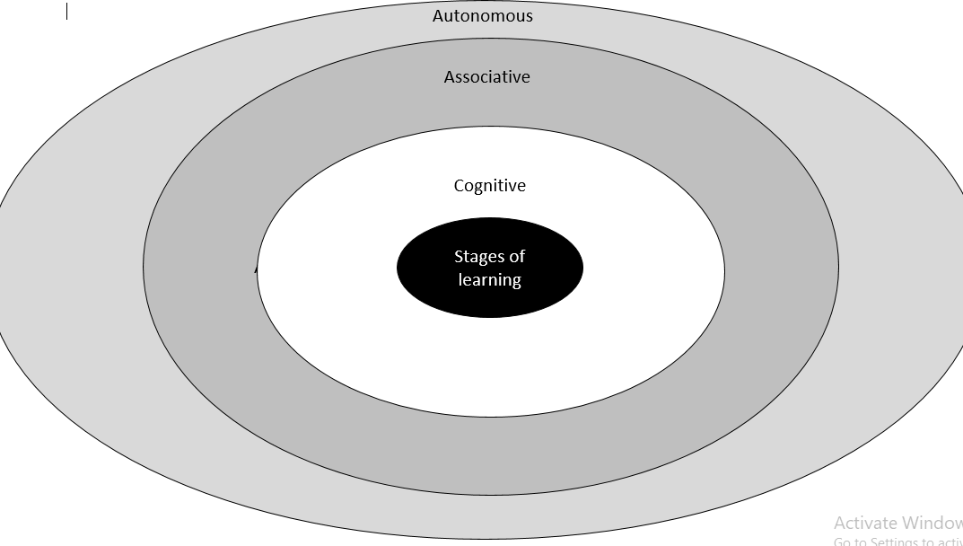

SPORT & SOCIETY
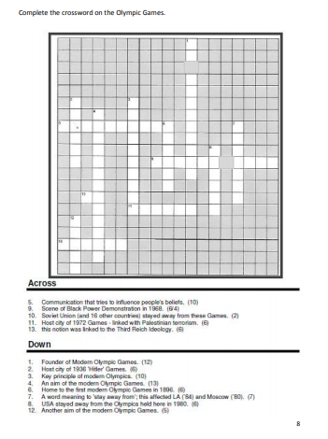

Task
Describe the positive and negative impacts on the host country/city of hosting a global sporting event (such as the Olympic Games or FIFA World Cup)

CONTEMPORARY ISSUES IN PHYSICAL ACTIVITY AND SPORT

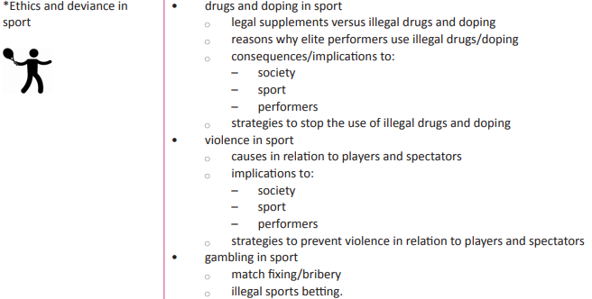

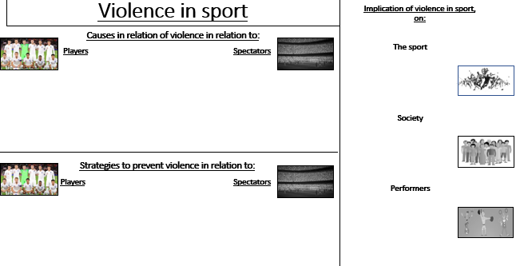

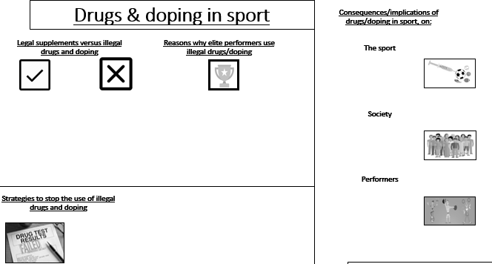

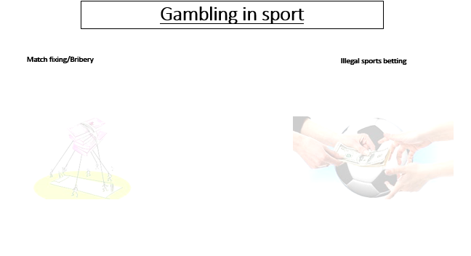

Complete this MOOC.  Football: more than a game  University of Edinburgh  This course is open now! | Listen to this radio programme from the BBC World service. Sports Hour is a live Saturday morning sports show with reports, debate and humour. There are over 280 shows available covering all world sport.  BBC World Service: Sports hour  BBC Programmes | Read this article which explores the science behind wearing a helmet in sporting activities and how helmets are there to stop brain fracture and not concussion.  Football helmets don't protect against concussion - and we're not sure what does  Ideas TED | Watch this TED talk  which explores how racial stereotypes have infiltrated the language we use to discuss athletes.  Shouldn’t sports be colour-blind  TED Talks – Patrick Ferrucci | Complete this course.  Exercise prescription for the prevention and treatment of disease  Future Learn  Available now or 4th May 2020
Listen to this radio programme.  This is a daily podcast bringing you the latest from the Premier League, EFL, European football and more.  BBC Radio 5 Live  BBC Programmes | Read this article  which explores some of the key gender issues in sports.  Sports are designed around men – and that needs to change  Ideas TED | Watch this TED talk.  Are athletes really getting faster, better, stronger?  TED Talks – David Epstein | Listen to this podcast in which Calum and Buncey react to KSI's split-decision victory over Logan Paul in Los Angeles.  KSI vs Logan Paul II  BBC Sounds | Watch this TED talk.  My 12 pairs of legs  TED Talks – Aimee Mullins
Watch this TED talk in which Valorie Kondos Field, long-time coach of the UCLA women's gymnastics team, shares the secret to her success. Hint: it has nothing to do with "winning."  Why Winning doesn’t always equal success  TED Talk – Valorie Kondos | Watch this TED talk in which Christopher McDougall explores the mysteries of the human desire to run.  Are we born to run?  TED Talk – Christopher McDougall | Watch this TED talk. How much do you know about intellectual disabilities?  Special Olympics let me be myself – a champion  TED Talk – Matthews Williams | Watch this TED talk.  Amazing, inspiring feats of daring and determination that will bring you everywhere from the high skies to the deep sea. (Playlist of eight talks).  Extreme sports  TED Talks | Listen to this podcast from the British Journal of Sports Medicine. It covers all sorts of aspects of Sports Medicine, from the science behind running shoes to the power of sleep.  BJSM Podcast  Also available on other podcast providers – search ‘BJSM’
LISTEN, WATCH, READ, STUDY
Highlight the tasks as you complete them

READING LIST
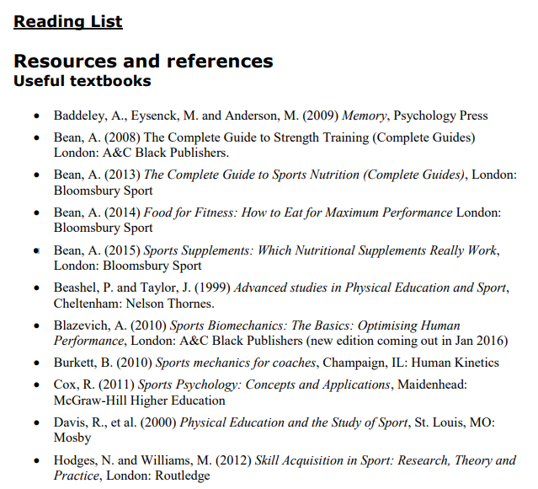
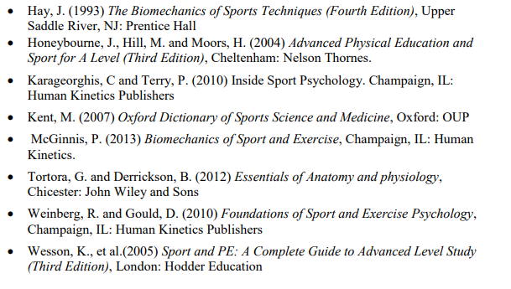

FACULTY EXPECTATIONS
There are some expectations that we set for all students who are studying A-level Physical Education.
Students are to provide a notepad, pens, pencils and a folder for their lessons, a folder for both the theoretical and coursework components will be required.
It is recommended that a USB storage device (memory stick) is also provided to transfer work to and from the school/home computers.
It is expected that students attend all lessons promptly and in the correct business attire. If a student misses a lesson it is expected that they will speak to the member of staff who taught the lesson and catch up with the work.
Mobile phones are not to be used in lessons and must be switched off
Students will be provided with homework and coursework to be completed at home or in study time at school. It is expected that all students will hand their work in for marking promptly and to the best of their ability.
The workload is considerable and approximately six hours per week should be completed at home as independent research/study.
In addition to lessons the PE Faculty endeavours to hold regular support sessions after school allowing students to complete work with extra guidance available.
We hope you manage to stay safe and remain active over the lockdown period and the summer holidays. We look forward to welcoming you in September 2020.
Tuxford Academy PE Faculty

