**Further Maths Bridging Unit**

Some of the content covered in Further Maths A-level is *very* different from anything you will have encountered before, both at GCSE and in your Maths A-level.

**Part 1: Matrices**

During your taster session you did some work on matrices. Here are some questions for you to have a go at.

1. This diagram shows a map of the roads linking 3 towns A, B and C. The corresponding ‘direct route’ matrix is shown beside it.

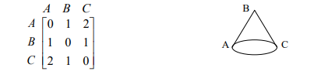

For each of the following diagrams construct the direct route matrix.

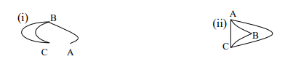

(2 marks)

1. 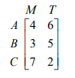A café sells 3 main meals A, B, and C each day. On two days the sales of each type are shown in the matrix. If meal A costs £4, meal B costs £5 and meal C costs £3 construct a matrix showing the amount taken for each of the meals on each of the two days. Hence state the total amount taken for each meal over the two days.

(2 marks)

1. Calculate, if possible,

(i) **A** + 2**B** (ii) **C** – **D** (iii) 3**A** – 2**C** (iv) 3**D** – **C**

(4 marks)

1. Calculate, if possible, the following

(i) **AB**  (ii) **AC**  (iii) **BC**  (iv) **BD**

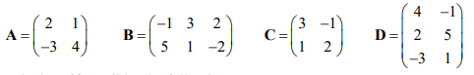

(8 marks)

1. 

(4 marks)

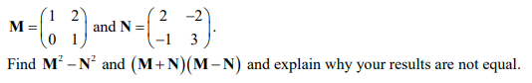6.

(7 marks)

**Part 2: Complex Numbers**

Complex numbers are another topic you will cover in Year 12.

1. Your next task is to do some research on what complex numbers are. *You shouldn’t spend longer than 45 minutes on this part*.

A website you may want to use and will use during Y12/13 is integral. The following log in details give you access to the website and this runs through examples. (It also has videos on matrices and other topics).

<https://my.integralmaths.org/course/view.php?id=84&sectionid=1757>

STUDENT ACCOUNT  
Username: amst-Tuxford1297  
Password: DerivativeDivergence808%

(10 marks)

NOTES:



Numbers of the form , where  is a real number, are called *imaginary numbers*, for example  or 

Numbers of the form , where  and  are both real numbers, are called *complex numbers*, for example  or 

Complex numbers are often given the symbol 

If  then its *conjugate* is given the symbol  and is defined by 

 multiplied by  is always a real number: 

If two complex numbers are equal then the real parts are equal to each other, and also the imaginary parts are equal to each other. We can form two separate equations by *equating real and imaginary parts*

If a quadratic equation has real coefficients and  then its two roots are complex numbers, which are always conjugates of each other.

1. In the following exercise,  and . Match each expression on the left with one on the right, and write your answers in the table below

|  |  |  |  |
| --- | --- | --- | --- |
| **A** |  | **1** |  |
| **B** |  | **2** |  |
| **C** |  | **3** |  |
| **D** |  | **4** |  |
| **E** |  | **5** |  |
| **F** |  | **6** |  |
| **G** |  | **7** |  |
| **H** |  | **8** |  |
| **I** |  | **9** |  |
| **J** |  | **10** |  |
| **K** |  | **11** |  |
| **L** |  | **12** |  |
| **M** |  | **13** |  |
| **N** |  | **14** |  |
| **O** |  | **15** |  |
| **P** |  | **16** |  |
| **Q** |  | **17** |  |
| **R** |  | **18** |  |
| **S** |  | **19** |  |
| **T** |  | **20** |  |

(20 marks)

|  |  |  |  |  |  |  |  |  |  |  |  |  |  |  |  |  |  |  |  |
| --- | --- | --- | --- | --- | --- | --- | --- | --- | --- | --- | --- | --- | --- | --- | --- | --- | --- | --- | --- |
| **A** | **B** | **C** | **D** | **E** | **F** | **G** | **H** | **I** | **J** | **K** | **L** | **M** | **N** | **O** | **P** | **Q** | **R** | **S** | **T** |
|  |  |  |  |  |  |  |  |  |  |  |  |  |  |  |  |  |  |  |  |

**Part 3: Discrete mathematics – Linear Programming**

Part of further mathematics is applied. You will dig deeper into mechanics and you will also learn about discrete mathematics. This is more about making decisions and logic thinking.

1. For this part, you should do some research on linear programming. The website given on Part 2 may be of use again, but there are lots of websites and youtube videos. *You shouldn’t spend longer than 30 minutes on this part*.

(5 marks)

1. Have a go at the following question.

A teacher is planning a trip for 174 students and 18 staff.

They will travel on minibuses and coaches.

Each minibus costs £40 and can take up to 16 people, including at least 2 staff.

Each coach costs £160 and can take up to 48 people, including at least 3 staff.

What is the cheapest way of arranging transport? How much will it cost altogether?

(8 marks)