English Literature A Level
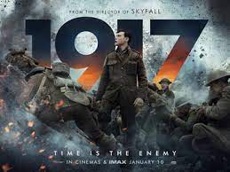 | Media  - Review Film ‘1917’  or  - Review podcast, website or blog on Sebastian Faulks or Pat Barker.  (20 points each)
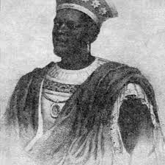 | History  - Read this article and reformat the information in the form of a mindmap.  https://www.blackhistorymonth.org.uk/article/section/author-and-historians/black-tudors-a-peak-into-the-lives-of-ten-people-of-the-african-diaspora-in-tudor-britain/  (40 points)
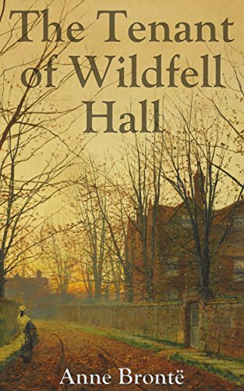  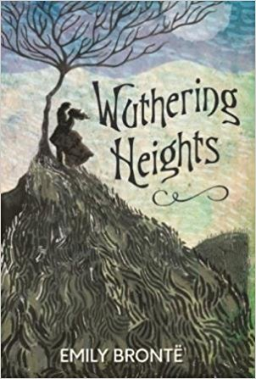 | Read with short review  - Anne Brontë’s The Tenant of Wildfell Hall  or  - Emily Brontë’s Wuthering Heights  (50 points each)
Note taking

Watch 3 videos and read 3 articles from the Imperial War Museum on WW1, making notes to discuss.
https://www.iwm.org.uk/

(50 points)
(You could visit the museum for another 50 points!)

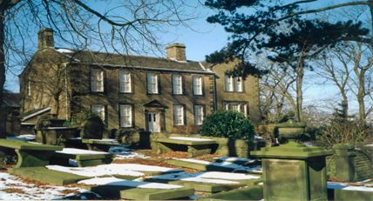 | Visits with short review  - Visit Jane Austen’s House Museum  or  - Visit Haworth Bronte Parsonage museum and research the Bronte sisters  (50 points each)
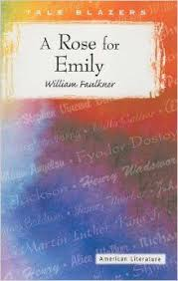  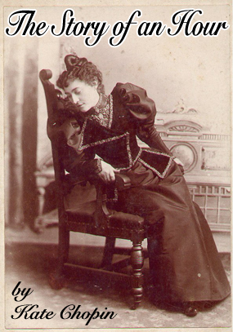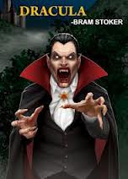 | Essay project  - Compare how Chopin and Faulkner present the position of women in ‘The Story of an Hour’ and ‘A Rose for Emily’ – essay. Both texts can be found as PDF documents online.  (100 points)

Reviews should be hand written or word processed reports which should include a general overview, 3 objective positive observations and 3 negative observations as well as your personal opinion. Reviews and reports should be between 400 and 500 words. Essay question should be around 1000 words long.

