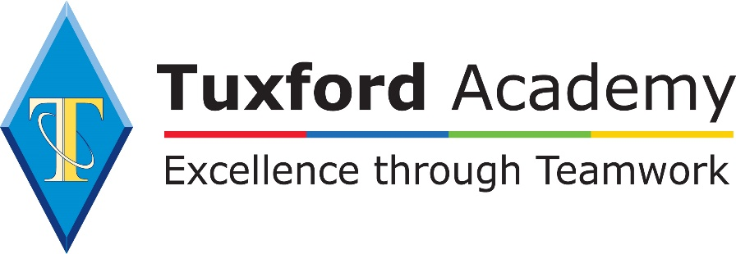

Digital Media Bridging Unit

Wider Reading
As part of your A-Level studies, and if you plan to go on to further study you will need to develop a wide understanding of Digital Media and how it impacts our lives. These books are a great place to start.
The Media Monopoly | Bagdikian, Ben | 978-0807061794
Shooting Better Movies: Student Filmmakers Guide | Dudbridge, Paul | 978-1615932719

Listen Watch Learn

Watch this video on making a good filmed advert.  How to make video ads  Youtube - Biteable | Complete this course to explore how films go from script to screen.  Explore Filmmaking  Future Learn | Read this article about the increase of digital media.  Digital overtakes offline media  The Guardian
Complete this course which gives an introduction to photo editing using PhotoPea  PhotoPea  Youtube - TodaysTuts | Listen to this radio article discussing whether we need social media.  Would the world be better without social media  BBC Sounds | Complete this course which explores the evolution of cryptography and how we use it in modern computing.  Imagineering in a Box  Khan Academy

Introduction to Media Conglomerates

The media industry generates billions of dollars of revenue every year, but did you know that much of the content you consume is generated by a small handful of multinational corporations which are known as conglomerates. These companies are able to create content, distribute and market it all within their own businesses.
Watch this video about the biggest media conglomerates.
https://www.youtube.com/watch?v=hl3Mi4pVwaM
Look at this infographic:
https://www.webfx.com/blog/internet/the-6-companies-that-own-almost-all-media-infographic/

A closer look
Disney is one of the biggest conglomerates owning a huge number of different well known broadcasting outlets, productions and distribution companies, record companies, publishing houses and, of course, its theme parks. In the last decade Disney has acquired a number of other franchises including Marvel, Star Wars and in March 2019, Fox. Disney uses all of these different branches of its business to maximise revenue and they will often advertise their new movies within their other media offerings, this is known as synergy.
Task: Carry out some research into the scope of the Disney Empire, identify the companies it has bought out, the assets these provided and the budgets involved. Then find two further examples of how Disney is using its network of different companies to advertise its films.

Disney Bigger than you know https://www.youtube.com/watch?v=r_0ra-sILKU
The Bachelor / Beauty & The Beast Edition https://www.youtube.com/watch?v=28eCsEKAud8
How Disney is Maximising Star Wars
https://www.wired.com/2015/11/how-disney-is-making-sure-youll-never-be-able-to-escape-star-wars/

Todorov’s Narrative Theory

Todorov’s theory on narrative identifies five steps within which traditional stories (films) all follow. This theory can be applied to most films and TV shows today.
Watch this video to help you understand the theory Todorov’s Theory
Task: In an appropriate report (MS Word) explain the theory and the underpinnings behind it before utilising an example from your own research which exemplifies this theory, using key plot points to explain your point. Where possible use printscreen images from these key plot points or scenes which aid this explanation. The examples which re-enforce your explanation should all come from the same example media text i.e. one film.

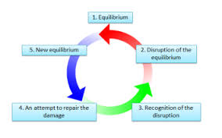
Audience

What would be the point of any media text if there was no audience to consume it? Within Digital Media studies, ‘audience’ refers to how different forms of media target, reach and address audiences. We also explore how to group people into audiences and how these groups respond differently to different media texts.

One way of grouping audiences together is by looking at their psychographic profile. Watch this video https://www.youtube.com/watch?v=xhby7s9OJv0 then carry out your own research into psychographic groupings.

Task: Produce an infographic (https://piktochart.com/formats/infographics/ ) explaining the seven different psychographic groups. For each group you should include a description of their personality, examples of media texts they would choose to consume and why they would choose these texts.

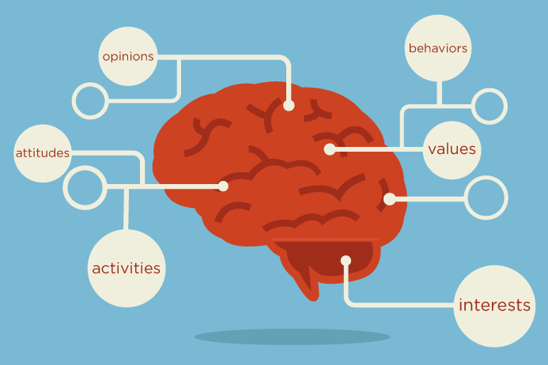
Representation

Representation refers to how the media portrays events, issues, individuals and social groups. What we see is actually what the media want us to see, representations change depending on how the media portray it to us. Many theorists such as Stuart Hall and David Gauntlett have explored the notion that the media do not actually reflect the world, they shape it through their representations.
Task: Watch this short film from the YouTube channel, ‘The School of Life’.
https://www.youtube.com/watch?time_continue=8&v=NwPdAZPnk7k

What is a stereotype?

Watch this video about what a stereotype is https://youtu.be/G5J-Xs50-Ik

Task: Identify 2 different stereotypes that exist within society? For example “Blonde females are less intelligent than their peers”
1.
2.

When identifying how something or someone is represented, we start off with 2 possible words, either positive or negative.
Task: Use one of the two words for the groups below then explain in detail why you have chosen that word. For example if you think footballers are represented negatively, why do you think that? What makes them negative? If you think footballers are represented negatively, why do you think that? What makes them negative?”
How are footballers represented to us?
How are politicians represented to us?
How are teenagers represented to us?
How is the NHS represented to us – how has this changed recently?
How are celebrities represented to us?
How are the police represented to us? How are the police represented in the USA?

Pitching a Product

A media product does not simply exist in a vacuum. There is much work to be done before the product is finally consumed by an audience. Like most commercial products, a media product starts life as an idea in the mind of its creator or creators who then have to sell the idea to those who have the means to produce it. To convince the producers that it is a good idea, the creator(s) have to show how the end product might look or sound, and convince them that there is a unique selling point to attract a particular audience.
Being able to deliver an effective pitch is an important skill when working in digital media.
Task: Write a short guide to delivering an effective pitch which includes the do’s and don’ts. The following videos and articles may help.
Bad Pitch https://www.youtube.com/watch?v=oq7Sx4VOJa0
Good Pitch https://www.youtube.com/watch?v=Vu3gVgCJx74
Pitching Advice Article https://startups.co.uk/how-to-pitch-to-a-dragon-with-deborah-meaden/

