Geography Bridging Unit

The following activities in this booklet are aimed to give you a taster of A Level Geography content, whilst developing crucial skills and knowledge in readiness for starting the course in September.

If you find any of the activities challenging and would like some guidance, please contact a Geographer:
Miss Ashton nashton@tuxford-ac.org.uk
Miss Pallant spallant@tuxford-ac.org.uk
Mr Holmes gholmes@tuxford-ac.org.uk
Mr Newsum-Smith jnewsum-smith@tuxford-ac.org.uk

When you have completed your bridging unit, please email the document to nashton@tuxford-ac.org.uk by 20th July 2020. This should include photos of any activities you have completed on paper.
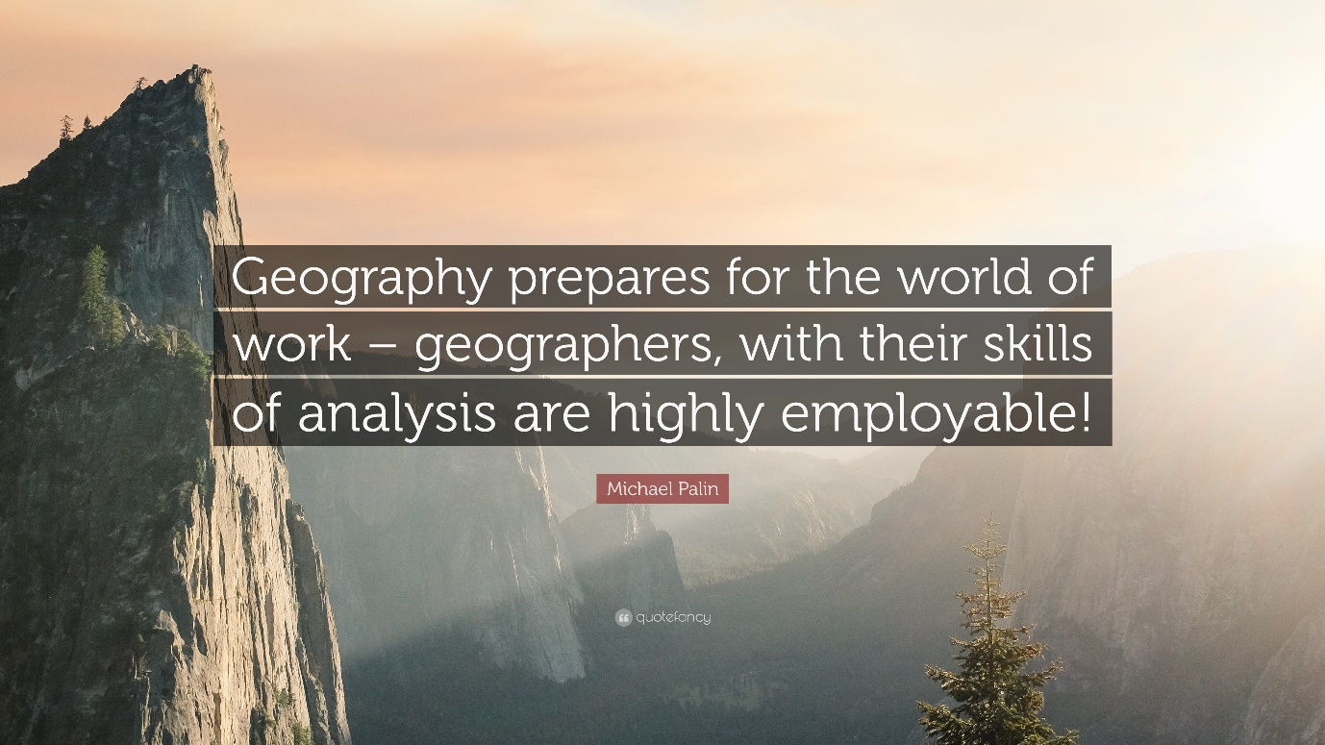
Essential A Level Skills
Many of the skills you will practise during these activities are transferable to other A Level subject areas. Even if you decide not to take Geography further the skills will still be useful to you at A Level and beyond.
- Notetaking (Contemporary Urban Environments)
It is important to be able to collate large volumes of notes from textbooks, articles and video sources in order to research the geographical theory underpinning each topic you will study. Therefore having a technique that allows you to organise your notes clearly, will help you to review and revise them for assessments. You will be learning the Cornell method of notetaking in this section.

- Classifying, categorising and visualising information (Hazards)

As a geographer you will need to sort the information you collate in your research into manageable chunks, so that you can remember a wide range of facts about places you will study in depth. Choosing the most effective way to present information to compare, contrast and make links between information will help you to analyse what is happening and allow you to apply the relevant knowledge to questions. You will be learning to master dual coding in this section.

- Source Analysis (Coastal systems and landscapes)

Geographers learn a great deal from observing the human and physical world around them. This allows you to understand patterns, processes, place and space whilst studying how people and environments interact with one another. This is key to decision making, therefore being able to describe, explain and suggest what you are observing provides a geographical context for the world we live in. You will be learning how to successfully annotate photographs in this section.

- Critical analysis and evaluation (Global systems and Governance)
Once a geographer has all of their research on a topic, they need to be able to reach a valid conclusion to the question they were investigating. This is done through making critical judgements (opinions) about the information. Often this means creating a persuasive yet factual argument through extended writing. In this section you will practise the PeEeEeEL & JEON techniques.

- Independent investigation (Changing Places; Water & Carbon cycles)

You will be required to create your own investigation into a geographical area of interest linked to the exam specification. This involves hypothesising a question, researching the theory, selecting appropriate methods to collect data, choosing relevant presentation techniques (maps & graphs), completing descriptive and statistical analysis (maths), critically concluding and evaluating the study. In this section you will follow a human and a physical investigation through these steps to familiarise you with the different stages in preparation for the A Level course.
- The Cornell method of notetaking

- Start by watching the youtube clip about how the Cornell Method works (She is an American Biology Teacher, but stick with it – its relevant)
https://www.youtube.com/watch?v=WtW9IyE04OQ&list=PLpmiWNoiQk68K3-aW2PYDFs6PDub9pmtW&index=1
You could even start practising the technique whilst watching this clip.

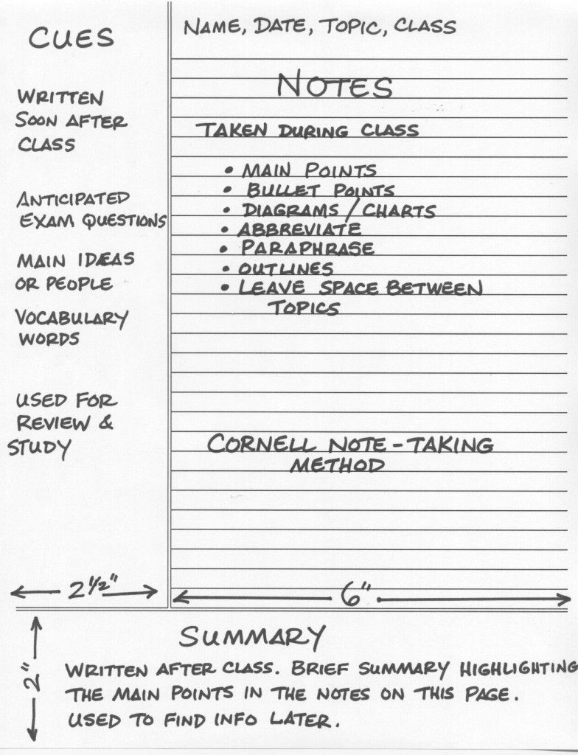
Figure 1: Cornell note taking template Figure 2: An example of the strategy in use

- Watch the video clip from the Geographical Association about urbanisation to introduce you to the Contemporary Urban Environments topic.

https://vimeo.com/151492843

Take notes using the Cornell method you learnt about above.
You can also choose to type on the template that follows or hand write your notes. If you choose the latter please include a photo of your notes on by replacing the template on the following page.

Complete Cornell notes on Urbanisation here or insert a photo
- Dual coding to classify, categorise and visualise information

- You are going to investigate the 2010 eruption of Eyjafjalljokull volcano in Iceland. Firstly you will need to research the eruption to find out what happened.
Watch the video clip and make notes using the Cornell method as good practice.

https://vimeo.com/280686404

See if you can add more facts to your notes by researching the eruption (Google)

- Now you have all the facts you need to create a one page visual display of the information. The starting point should always be to think about what categories and classifications we use in Geography to sort information. Look at the Figure 3 on the following page to help you.
Here are some examples to help you think about layout, links between information and categories you may wish to use.
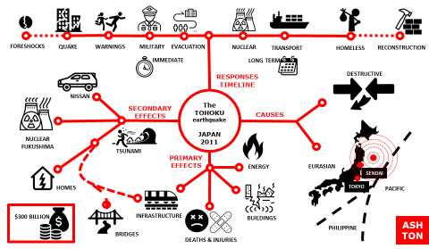
c) Once you have organised your layout the next step is to add icons. You can either draw these if doing it by hand or you can search for icons, such as those in the examples using:
https://thenounproject.com/
d) Insert your case study into the document.

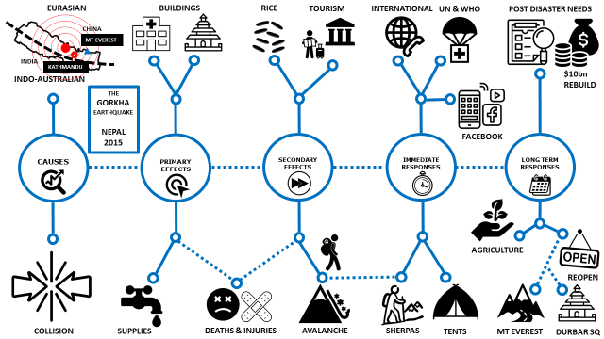
e) Talk someone else through your case study using your notes to give them lots of extra facts.

f) Now without looking try to redraw your visual from memory. When you have finished evaluate your success with a WWW and EBI.

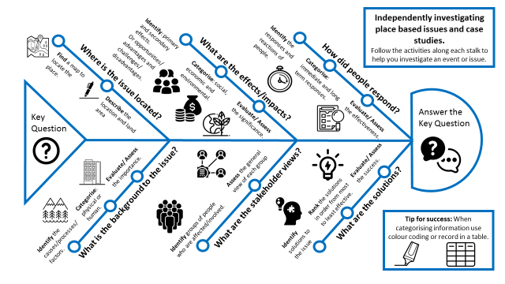
Figure 3: Guide to sorting case study information
Eyjafjallajokull Cornell Notes (insert below)
Eyjafjallajokull dual coded visual display. (Insert below)

Insert your drawing from memory with a WWW and EBI
- Annotating photographs to analyse a source
a) Study the examples below. Figure 4 shows a labelled photo, whereas Figure 5 shows an annotated photo. What is the difference?
________________________________________________________________________________________________________________________________________________________________________________________________________________________________________________________________________________________________________________________________________
Figure 4: Labelled Photo of High Stacks at Flamborough Head
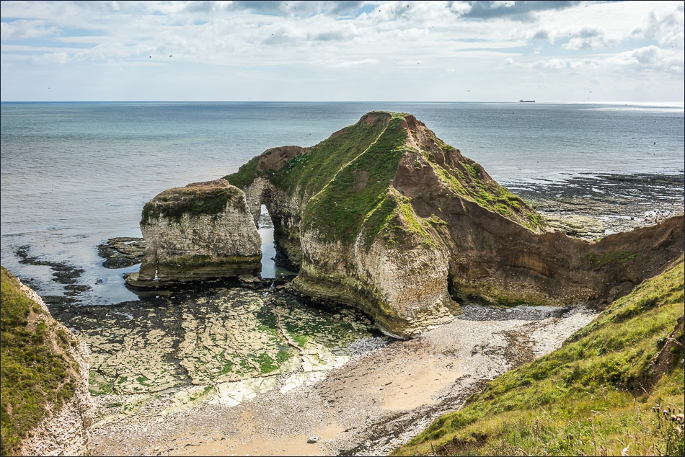
North Sea
Chalk cliff
Arch
Boulder Clay
Wave cut platform
Beach
Vegetation
Erosion

Figure 5: Annotated Photo of High Stacks at Flamborough Head
View looking south across the North Sea from Flamborough Headland
Weather is calm leading to low energy waves
Cliffs are composed of chalk with clear faultlines showing weakness susceptible to physical and chemical weathering
A developed wave cut platform and notches , showing that erosion is a dominant process and the cliff line is in retreat
Arch is well developed showing erosional processes such as hydraulic action and abrasion are significant.
Boulder clay tops the chalk cliffs, which is less resistant to weathering and erosion processes
Vegetation is established on the cliff top, showing a stable cliff with little erosion; however, there is less coverage on top of high stacks showing potential biological weathering and mass movement
The beach is narrow and made up of a mixture of sand and chalk pebbles
The tide is low shown by the exposed rocky platform and the marks for high tide on the cliff base
Development of a cave being eroded from a fault through wave quarrying
b) Now it is your turn to annotate the photograph below.
The photo shows the sea defences at Hornsea.
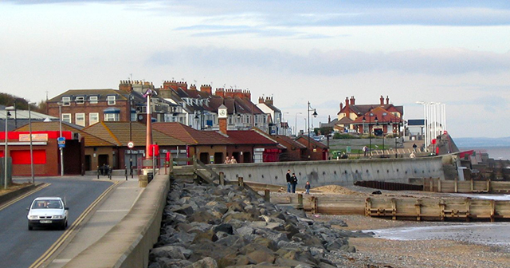
Use your prior knowledge and any further research to annotate the photo to show how Hornsea is being defended and evidence of its success.
- Critical analysis and evaluation of the Shrinking World
The economic world is constantly changing as technological advances continue to aid develop around the globe leading to the virtual shrinking of world in which we live.
a) Study the information from geography Review magazine about how our world is shrinking.
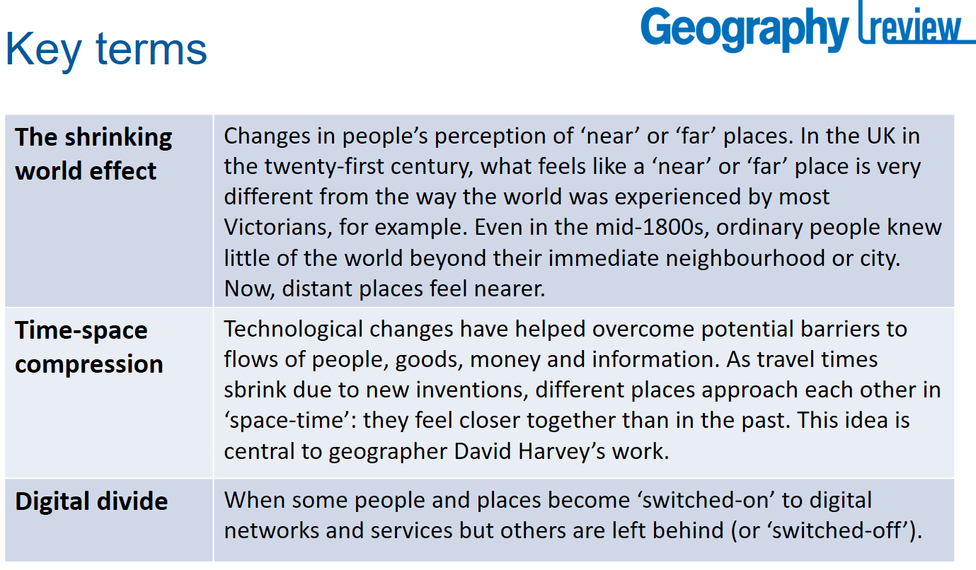
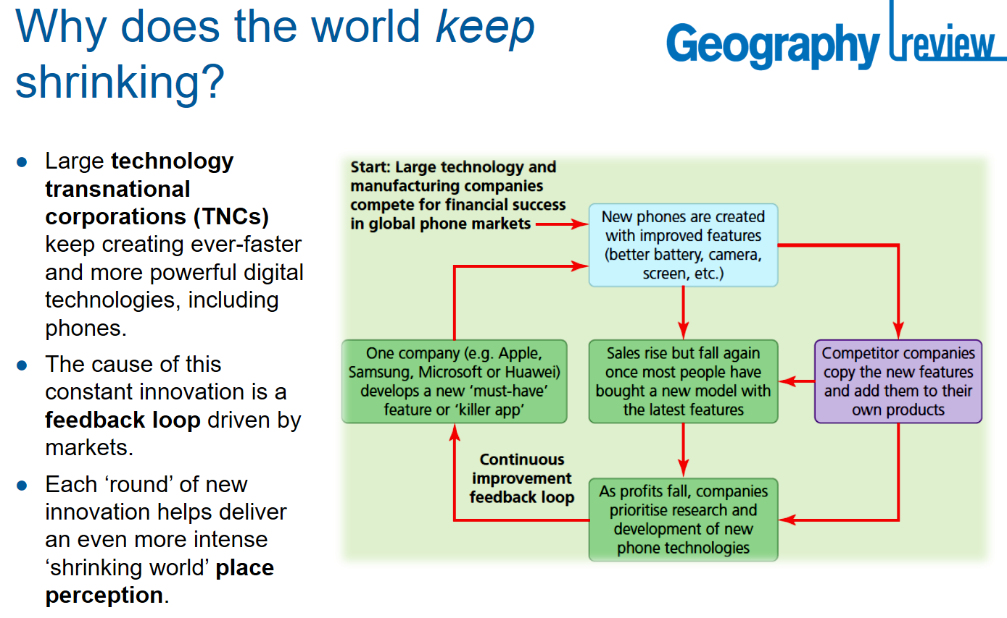
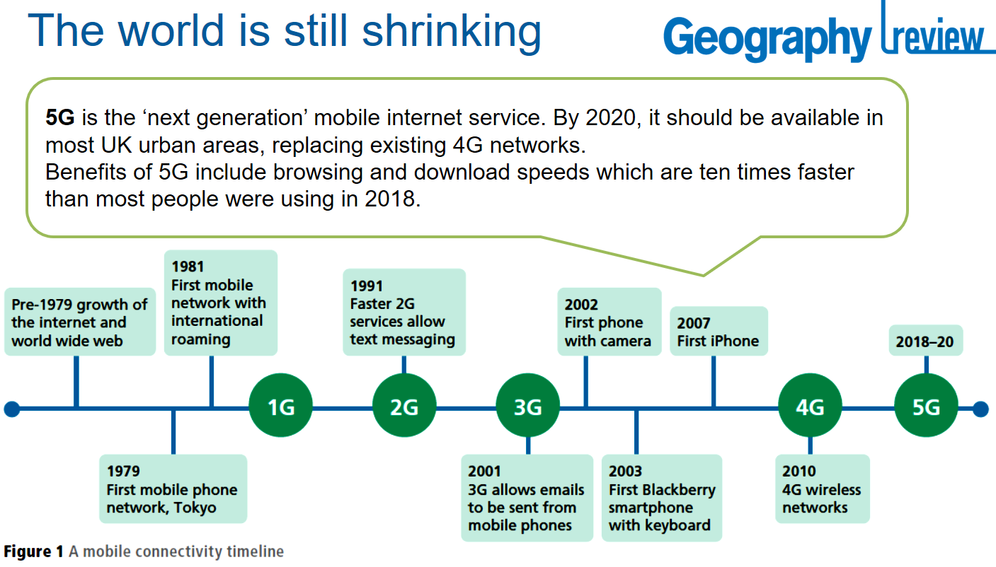
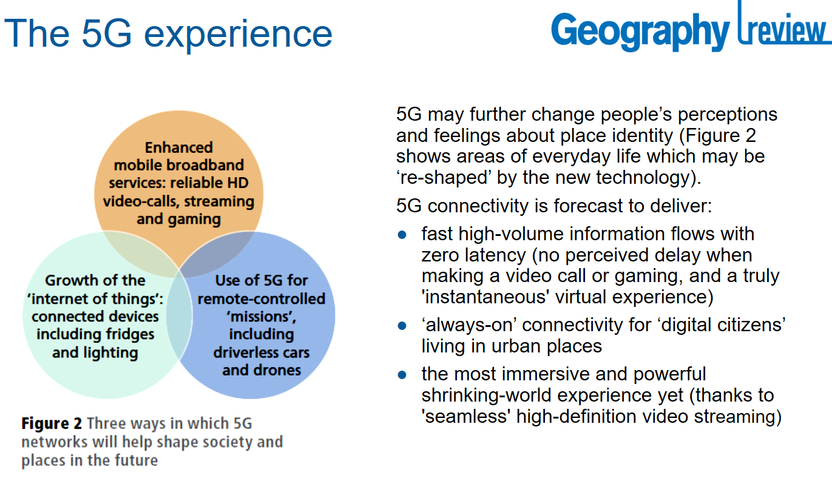
b) You are going to answer the following question:
To what extent are technological advances having a positive impact on people globally?
- First you should identify 3 pieces of evidence that show how technology has been positive.
- Secondly you should identify 3 pieces of evidence that show how technology may not be positive.
You can then create 2 PeEeEeEL paragraphs to create the persuasive sides of the argument.
P = Technological advancements has had a significant positive impact on people’s ;lives.
e = For example… (Put your first piece of positive evidence here)
E = This has meant that… (explain the evidence further)
e = Another example is… (second piece of evidence)
E = This has led to… (explain further)
e = A final example is… (third piece of evidence)
E = This shows that… (explain further)
L = Therefore this shows that technology has been economically/socially positive because…

Use the above writing frame to help you with the second paragraph about the negative side of technology.
c) Finally you should reach a conclusion to show how positive or negative you think technological advancements have been.
J = In conclusion technological advancements have had a positive impact to ___________ extent.
E = This is because..
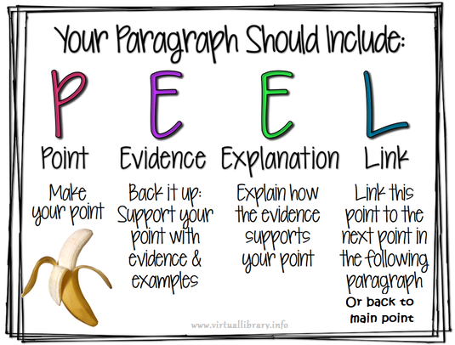
O = On the other hand…
N = Nevertheless…

Extra TIPS: When writing a link or conclusion do consider the big geography concepts such as physical vs human; economic, social and environmental; LICs vs HICs; Local Vs Global; Short vs Long term; Rural vs Urban. These concepts will help you to conclude generally.

To what extent are technological advances having a positive impact on people globally?
Space for answer
- Independent investigation:
You are going to follow two lines of enquiry. You will complete the pre learning activities below followed by completing your fieldwork methods via watching a “live” lesson from the Field Studies Council.
Investigating Place: Human Geography: Pre Live Lesson Learning
a) What is Place?
This concept is complex and contested by geographers but some definitions include…
“Place, at a basic level, is space invested with meaning” (Cresswell, 2004)
Place is defined as a location with meaning. The meaning could come from personal experience or a wider, social or cultural meaning. Defining place can be thought of with 3 academic approaches. These are listed and described below. Thinking of a familiar place, e.g. your school or town, can you give some of your own examples of each type of approach to place and factors that might influence it?
Descriptive approach | Social-constructivist approach | Phenomenological approach
This means when a place is defined by measurable characteristics | This means when a place is defined by or given a meaning by wider society | This means when a place is defined by a person’s experience (real or imagined)
e.g. a school’s number of pupils | e.g. Manchester seen as busy, hard-working, industrial from its bee emblem | e.g. exciting (tourist in New York), peaceful (an elderly person in their town park)

Key terms hint: we call factors that shape a place endogenous factors (factors within a place that shape it, e.g. the demographic structure) and exogenous factors (factors from outside, e.g. inward investment from a Transnational Corporation).
b) Exploring a place
Now we know what we mean by the idea of Place, we can start looking at this in context, as geographers using the three approaches. Our investigation aim is:
Investigate how a location is experienced and perceived by different people.
To start investigating a place, we need to research using some background information about a place.
Using the ArcGIS Storymap https://bit.ly/fieldworklivePlace , we are going to explore Dedham. Click through the Story Map, completing tasks as you go. We will think about why we have chosen Dedham shortly, but as you go, take notice of the sources of data we are using to explore a place. This could be useful in your future studies!

(i) Using facts from the different map data layers, select and describe 3 characteristics to describe Dedham
__________________________________________________________________________________________________________________________________________________________________________________________________________________________________________________________________________________________________________________________________________________________________________________________________________________________
(ii) Select one of John Constable’s paintings of the area from the Storymap. Fill in this Image Analysis template to define how this famous representation of Dedham might shape people’s perceptions of it.
Painting chosen:____________________________________________________________________
Identify a main feature of the image | What perception might people have of Dedham, looking at this image? Explain this if you can and link to your wider geographical knowledge.
e.g. Rural/ farm workers | Agriculture is a primary industry. On the Clark-Fisher model, a reliance on primary industries, which is all that is shown in the painting, suggests a preindustrial, more basic way of life. This might make people think of Dedham as a traditional area.

(iii) Gilbert’s 8 way thinking helps us to explore different ways of understanding and experiencing place. On the Storymap, there are a number of views of the village. Select one and, using any 3 of Gilbert’s 8 ‘intelligences’ (ways of thinking), describe Dedham as a place from your perception:
Intelligence | Your description of Dedham
Linguistic intelligence – words and language. Adjectives, adverbs, similes to describe Dedham?
Logical-mathematical intelligence – numbers and logic. Can you describe this place with any numbers? E.g. number of cars/people? Percentage of green space?
Spatial intelligence – images and space. What are the key things you can see? What stands out?
Bodily-kinaesthetic intelligence – body movement, control. What types of actions can you see here? Could be done here?
Musical intelligence – music, sound, rhythm. What might you hear in this space? Are sounds loud, quiet? Would they have a positive or a negative impact?
Interpersonal intelligence – other people’s feelings/ what people are doing/ how they’re interacting?
Intrapersonal intelligence – self-awareness. How would you feel here?
Naturalist intelligence – natural environment. What signs of nature are there? Habitats? Green spaces to use? Impacts of climate change?
- Why do you think Dedham might be a good place to study this investigation aim?
__________________________________________________________________________________________________________________________________________________________________________________________________________________________________________________________________________________________________________________________________________________________________________________________________________________________________________________________________________________________________________________________________________________________________________________________________________________________________________________________________________________________________________________________________________________________________

Watch the Live Lesson and complete the following activities. https://www.youtube.com/watch?v=2DW3WOt7lvE
- Fieldwork Method 1: Non-participant observation of interactions and use of space
This method involves the researcher making qualitative observations of people using and experiencing a place. The researcher does not participate in the activities going on but observes behaviour passively.

People’s use and experiences of Place | Description of features | Your observations of fieldwork site
Appearance, clothing, age, gender, physical appearance of users of area | Note down anything that might indicate membership of a group such as profession, social status, socioeconomic class, religion or ethnicity
Physical behaviour and gestures | What are people doing? Running, walking? Body language, are they looking around the space or looking down? Behaviour and gestures towards other
Interactions with each other (verbal/ non-verbal) | Are people communicating with each other? Who does what, who interacts with whom, who is not interacting? What is the manner of communication?
Use of space | How are people interacting in the space? What are they doing? Where do they go? Which service do they use? Which routes do they take? Is this a transient place or do people congregate?
People who stand out | Does anyone stand out in the environment? How and why? What are their characteristics? What are they doing?

Evaluation of Non-participant observation method: note here any pros or cons we identify

Fieldwork Method 2: Place check
This method involves observing the features and characteristics of the place around you. Guided by ‘What makes this place...’ column, record your qualitative observations to define the range of ways that people’s experiences and perception of a place might be shaped.
METHOD HINT: Try to consider the questions from a range of users’ viewpoints e.g. over 70s, families etc. How might this improve or detract from our data?

What makes this place… | Your notes/evidence
... a special place?
• What makes this place special or unique?
• Why does it look the way it does?
• What local activities/events have shaped its look?
• Why do we like this place?
• What can we make more of?
• What potential is there to enhance the place?
... a well-connected, accessible and welcoming place?
• How accessible is it? What limits connectivity?
• How welcoming is it here? Is anything confusing?
• How well does parking work?
• How can it be made more welcoming and accessible?
... a safe and pleasant place?
• What makes the streets/public space here safe?
• What detracts from the safety and pleasantness?
• How safe are the pavements/ road?
• How can safety and pleasantness be improved?
• How do people enjoy nature? What is missing?
... a planet-friendly place?
• What makes this place planetfriendly?
• What resources are wasted?
• How does movement use resources?
• How is waste handled?
• How is energy used in buildings?
• How adaptable/resilient is this place?
• How could this place make better use of resources?
Evaluation of Placecheck method: note here any pros or cons we identify

Fieldwork Method 3: Emotion mapping
For various sites around a Place, use the mood record sheet (on the next page) to pick a colour and number for the mood you feel in that place as a measure of your perception. Record your number (1-7) and colour (as r, g, b or y) in the exact point where you feel it. For example, if you feel relaxed in that place, put ‘g 5’.
Your results | Colour | ‘Strength’
Emotion for Fieldwork Live site

Emotion for your Dedham site (viewed on Google Street View or the Storymap)

Evaluation of Emotion mapping method: note here any pros or cons we identify

Now try submitting some further observations for the place you are working from now. We will use Survey 123 to do this, follow this link https://bit.ly/fieldworklivePlaceData . This will help us capture an extensive big-dataset for how people feel about their place right
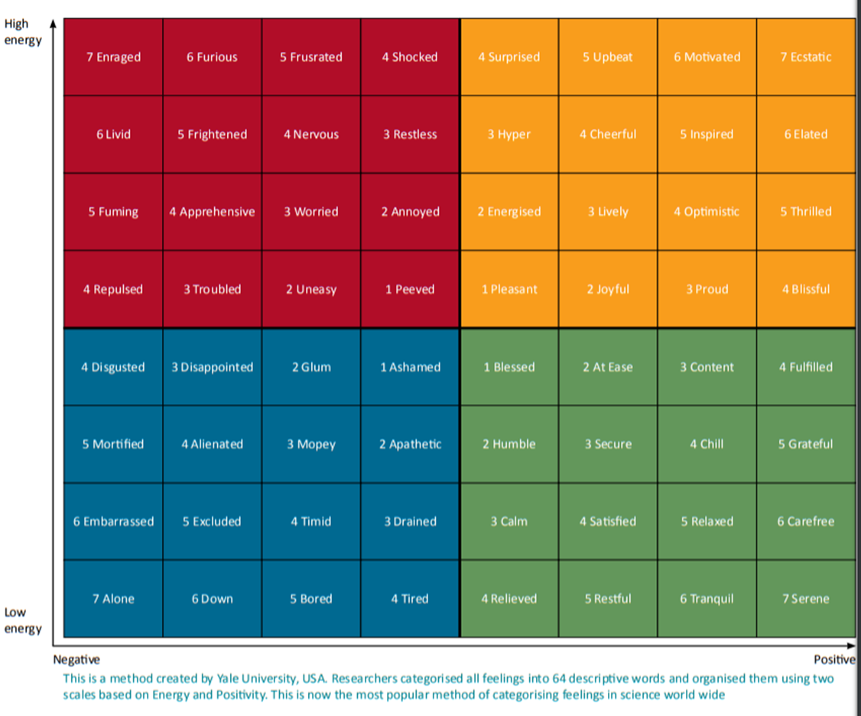

Investigating Flooding: Physical Geography
Pre Live Lesson Learning
A drainage basin is an open system, with water (matter and energy) able to enter and leave (inputs and outputs) across the catchment watershed (boundary between systems). Geographers use a ‘systems approach’ to simplify these complicated processes.
- The hydrological cycle within the drainage basin
Watch the drainage basin hydrological cycle learning video. Take note of how ‘stores’, ‘flows’ ‘inputs’ and ‘outputs’ are defined within a drainage basin www.youtube.com/watch?v=8GOJ3S5jKSI
Using the key words on the diagram, classify them as stores, flows, inputs or outputs. If you are unsure, or any terms are unfamiliar, star them and come back to them at the end.

- The flood hydrograph
The characteristics of any drainage basin and the climate will affect the likelihood and severity of flood events. A flood hydrograph is a graph that shows how a river responds to a period of rain.

Using your prior knowledge from GCSE, can you explain how the following characteristics will affect the hydrograph? (As an example one has been done for you.)

Antecedent conditions | The conditions occurring before (7-10 days prior). After heavy rain, for example, the soil becomes saturated: water will be unable to infiltrate and will flow into the river more quickly as surface run off. Lag time of the flood hydrograph will be reduced, the rising limb of the hydrograph will be steeper, peak discharge will occur sooner.
Geology (permeability of rock
Precipitation
Soil type
Elevation and Topography
Drainage basin density
Land use
- Interrogation of research location
Now we know the theory of how catchment characteristics might affect flood risk, we need to apply that knowledge to the study location for the investigation.

Use the information in the Story Map to help you identify and explain how the characteristics of the Upper Aire catchment might influence flood risk there.
https://bit.ly/fieldworkliveHydrology

Elevation & Topography | Land Cover
Rainfall | Geology

How have these secondary data sources been useful in the investigation planning process?
___________________________________________________________________________________________________________________________________________________________________________________________________________________________________________________________________________________________________________________________________________________________________________________________________________

Are there any limits to the reliability, precision or validity of the secondary data affecting the accuracy of our research?
___________________________________________________________________________________________________________________________________________________________________________________________________________________________________________________________________________________________________________________________________________________________________________________________________________

What makes the Upper Aire catchment a suitable place to investigate the hydrological cycle?
___________________________________________________________________________________________________________________________________________________________________________________________________________________________________________________________________________________________________________________________________________________________________________________________________________

- Developing geographical Enquiry Skills
Climate change has caused an increase in major flood events on both a global and national scale in recent years, therefore the importance of investigating the hydrological cycle has never been greater.

Yorkshire Dales hit by flooding following heavy rain
https://www.bbc.co.uk/news/uk-england-york-north-yorkshire-51597105

The fieldwork investigation is set within the Upper Aire catchment. The water from the catchment flows into the Malham Beck and the River Aire. Using ideas from the Storymap, photos and the article above, explore why flooding might be a risk in the area and why understanding the water cycle system helps to manage it. This will give geographical justification to our study.

What can we investigate about this place and why?
What flows and stores of water are there in this landscape?
What features of this landscape would affect flood risk?
To investigate our aim, what quantitative data could you collect here?
And what qualitative data could you collect here?
How might investigating the catchment help manage future flood risk?
Any questions for the Live Lesson?

Watch the Live Lesson and complete the following activities. https://www.youtube.com/watch?v=l-nlhvX98ls
- Storm simulation measurements
We will see the impact of different land uses on surface run off as a process within the hydrological cycle and apply this to the drainage basin.
As we look through the storm simulation method, note any limitations and justifications of the method below.

Validity | Reliability
Precision | Representativeness
Overall, is this an accurate data set?

- Storm simulation predictions
If we consider this in the context of the drainage basin, can you annotate the photos below with ideas of how surface runoff might vary in different areas? How will this, in turn, affect the likelihood of flooding?

Command word advice: When you are asked to annotate a resource, you are being asked not just to label it but to expend your label into a description and explanation of that feature. Look at the one done for you as an example.

- Determining soil texture
Take a sample of soil and use this key to determine the soil texture.
Soil texture observation notes for your location

What does it tell you? (validity) | Justify the method: Reliability? Precision? Representativeness? | Any limitations to the accuracy of the results?

- Recording the infiltration measurements
Record the findings in the table below
Time (minutes) | Water level on ruler (mm) | Drop (mm) |  | Infiltration rate (mm / hr)
0
1
2
3
4
5
6
7
8
9
10
Mean infiltration rate =

Calculating your Infiltration rate

• Work out the drop (mm) each minute from the difference in each reading
• Multiply your drop 60 (mins to hours) to work out the infiltration rate (mm/hr)

Why is infiltration rate a valid measurement for our investigation?
___________________________________________________________________________________________________________________________________________________________________________________________________________________________________________________________________________________________________________________________________________________________________________________________________________

Why are we measuring in mm and not cm
___________________________________________________________________________________________________________________________________________________________________________________________________________________________________________________________________________________________________________________________________________________________________________________________________________

Can you identify any other justifications or limitations of our method?
___________________________________________________________________________________________________________________________________________________________________________________________________________________________________________________________________________________________________________________________________________________________________________________________________________

How might these impact on the quality of our data and our conclusions?
___________________________________________________________________________________________________________________________________________________________________________________________________________________________________________________________________________________________________________________________________________________________________________________________________________

This recording has been taken in one location, can you suggest another location where the rate might be different and explain why?
___________________________________________________________________________________________________________________________________________________________________________________________________________________________________________________________________________________________________________________________________________________________________________________________________________

What sort of sampling strategy could be useful in getting a representative sample based on your last answer?
___________________________________________________________________________________________________________________________________________________________________________________________________________________________________________________________________________________________________________________________________________________________________________________________________________

Use this link https://bit.ly/fieldworkliveHydrologyData to add your soil texture and soil infiltration rate (mm/hr) data from your own experiments. We are using the Survey 123 app to collect a geo-located big data set.

Why might it be useful to create a large geolocated dataset for soil type and soil infiltration?
___________________________________________________________________________________________________________________________________________________________________________________________________________________________________________________________________________________________________________________________________________________________________________________________________________

What further investigations could be done with this big dataset?
___________________________________________________________________________________________________________________________________________________________________________________________________________________________________________________________________________________________________________________________________________________________________________________________________________

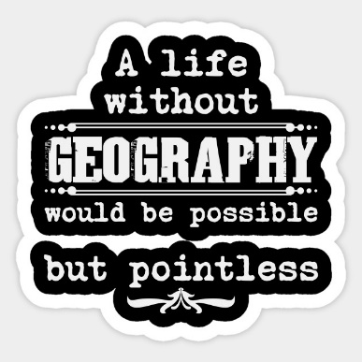
BONUS EXTRA: If you have enjoyed learning about Geographical Skills then check out https://www.geography-fieldwork.org/a-level/#primary-nav
You could even design your own mini study on your local area using the resources as a guide.

Congratulations you have completed you’re A Level Geography Bridging Unit.

ONCE A GEOGRAPHER, ALWAYS A GEOGRAPHER!
The geography department would love for you to continue to stay cognitively engaged over the coming weeks and months. The following are suggestions, they are not compulsory, but we would love for you to engage in any that you find interesting.
Press Ctrl + click on the link to access these suggestions.
BOOKS | 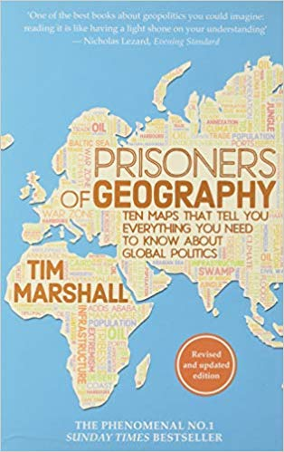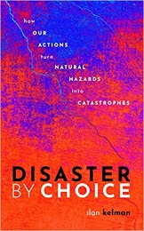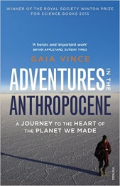

JOURNAL ARTICLES | 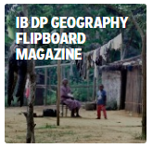

FILMS | 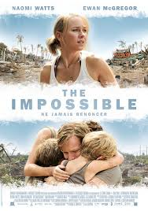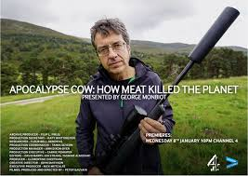

PODCASTS | Overheard – National Geographic Podcast  Science Weekly – The Guardian Podcast  Ask the geographer Podcasts  The Development Podcast – World Bank  The World Economic Forum Podcasts | Planet Money – The economy explained  RGS Online Lectures  BBC Costing the Earth  BBC The Documentary Podcast  Living Planet Podcast

TELEVISION | World economic forum videos  Royal Geographical Society Youtube  iPlayer Science and Nature Playlist  iPlayer Climate Change Playlist  BBC Earth | iPlayer Earth from Space  iPlayer Stacey Dooley on BBC Three  iPlayer Race Across the World  iPlayer Africa with Ade Adepitan  iPlayer Fashion Conscious

You might want to enter the
RGS Young Geographer of the Year - Launches April 2020

'The world beyond my window'

