SOCIOLOGY BRIDGING UNIT
2020

Tuxford Academy

Head of Sociology: Miss Cluley lcluley@tuxford-ac.org.uk

Contents
Topic | Page number | Tasks to complete | Completed?
What is sociology? | 3 | N/A
Self reflection | 4 | Answer the questions
Sociological theories | 5 | Create a poster on each theory using prompt questions
Sociology of social media | 6- 7 | Complete task 1-5
Dissecting articles | 8 | Read the articles and answer questions
Once a sociologist, always a sociologist! | 9 | Write a review of one of the books/podcast/video/news article
Preparing for sociology | 11 | N/A

This research-based project is designed to give you an ideal grounding for A-level study.
Research and complete all of the tasks to give you a good idea of what to expect on a Sociology course. If you then choose to study Sociology this will give you a good head start for your A Level Sociology.
Present the tasks in any format you like – this could be a powerpoint or a poster, or a leaflet, or word processed on an A4. Please keep all your work together.
If you are new to sociology and have not studied the GCSE- do not worry! Most of the topics we will cover, haven’t been studied at GCSE so the information will be new to everyone.

What is sociology?
Sociology is an exciting subject that challenges your everyday experiences.
It is the study of the relationship between the individual and society.
Sociologists are interested in why society works in the way that it does and the extent to which our behaviour and opportunities can be shaped by our social class, age, gender and race.

Self reflection
This is an opportunity for you to explain why you have chosen A Level Sociology as one of your option subjects. This will also give me an indicator about your interests, and what you are looking forward to studying.
Answer the following questions;
- Why have you chosen sociology? (be honest- some students pick sociology because it is something new- tell me what you are looking forward to doing in the lessons)
- What do you think sociology is about?
- How do you think sociology will help you in the future?

Sociological theories
In sociology, we study society from different sociological perspectives. As you get further into the course, you will figure out your own preference in regards to which theory you think suits your own views the most.
We will examine each topic and examine how each theories view the key debates. Some of our theories completely agree with one another, some completely disagree!
For each theory research the following questions.
- You need to present this so each theory has it’s own page. This will be a sheet you will use for most of your course!
- Do not simply write a question and answer- full sentences and paragraphs are expected
- Do not simply copy and paste!

The main theories we will use are;
- Marxism
https://www.tutor2u.net/sociology/topics/marxism
- Who founded Marxism?
- Why are Marxists a conflict theory? Who do they believe are in conflict?
- Why do Marxists disagree with capitalism?
- Who are the bourgeoise? Who are the proletariat?
- What would the proletariat eventually do according to Marxists?
- Functionalism
https://www.tutor2u.net/sociology/topics/functionalism
- Who founded functionalism?
- Why are functionalists a consensus theory?
- What did functionalists mean by the organic analogy? Explain what this means
- What do functionalists mean by anomie?
- Feminism
- What do feminists mean by patriarchy?
- Research the four types of feminism– Radical, Marxist, Liberal, Black
- Interactionism
- How do interactionists do their research? And what do they look for?
- Explain labelling theory?

The use of social media- a sociological approach
You are going to look at and investigate sociological views on the use of social media.
In 2016, there was a huge sociological study conducted by UCL (university of Central London), called ‘Why we post’.
These sociologists spent 15 months living in 9 communities around the world, researching the role of social media in people's everyday lives. The communities they visited and compared the roles of social media were;
- Industrial China (a factory town in South China)
- Rural China ( a rural town in North China)
- Southeast Turkey (close to the Syrian-Turkish border)
- North Chile
- Trinidad (one of the least developed areas)
- South England (two villages)
- Northeast Brazil
- South India (5 villages)
- South Italy
The researchers conducted a variety of research methods to find out the information they needed to look at how social media was used in different countries. They found 3 main discoveries
- Discovery 1: Social media is not making us more individualistic
- Discovery 2: For some people social media does not detract from education - it is education
- Discovery 3: There are many different genres of selfie

Task 1: watch the video https://youtu.be/0jA5B32MP98
In 200 words summarise what the research set out to do and how they did it in each community. Explain how they defined social media
Task 2: go to https://www.ucl.ac.uk/why-we-post/discoveries/1-social-media-is-not-making-us-more-individualistic/index
This is Discovery 1: Social media is not making us more individualistic
Summarise the findings on how social media is used in each community. Be clever about how you present this, it could be a poster, powerpoint or an infographic
Task 3: go https://www.ucl.ac.uk/why-we-post/discoveries/2-social-media-is-education
This is Discovery 2: For some people social media does not detract from education - it is education
Summarise the findings on how social media is used for education in each community. Be clever about how you present this, it could be a poster, powerpoint or an infographic
Task 4: go https://www.ucl.ac.uk/why-we-post/discoveries/2-social-media-is-education
This is Discovery 3: There are many different genres of selfie
Summarise the findings on how selfies are used in each community. Be clever about how you present this, it could be a poster, powerpoint or an infographic
Task 5:
Write a 500 word summary about your use of social media, staying focused on the themes in from UCL’s research.
Below are some questions that will help you with your summary:
- Go to your phone (you may have to google how to do this depending on your phone) state how many hours you spend on social media a day
- Which social media accounts do you have?
- Why do you use social media? Is it a form of expression, to communicate, for likes? Etc?
- How does social media support you with your education? Does it not? What is your opinion on how phones should be used in school?
- Do you ever post selfies? Why? Do you avoid selfies and prefer group pictures or portraits etc?

Dissecting articles
As part of your study for A Level Sociology, it is vitally important that you explore the latest current affairs through the different news outlets. The students who achieve the best grades, use their knowledge of current affairs to support their essay answers.
Task 1:
Read the following article: https://www.tes.com/news/few-one-20-born-poorest-areas-go-university
Answer the following questions;
- What is meritocracy?
- Does this article suggest we live in a meritocracy?
- Why is it important that ‘poor’ students go to university?
- Why do you think the most disadvantaged don’t go to university?
Task 2:
Read the following article: https://www.theguardian.com/lifeandstyle/2018/jan/29/the-seven-apps-every-woman-should-own
In 500 words, explain how radical and liberal feminist would respond to this article

ONCE A SOCIOLOGIST, ALWAYS A SOCIOLOGIST!
The Sociology department would love for you to continue to stay cognitively engaged over the coming weeks and months, despite the cancellation of this year’s exams. The following are suggestions, they are not compulsory, but we would love for you to engage in any that you find interesting.
Task: A sociological review (500 words)
Choose either a book, film, podcast or blog/news article- just one!
Write a review explaining;
- What you learnt
- What were the most interesting things you found?
- Did you agree with everything said?
- What did it make you question or think about?

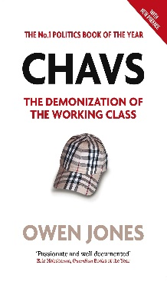
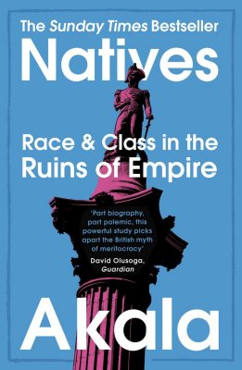
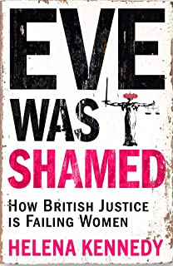
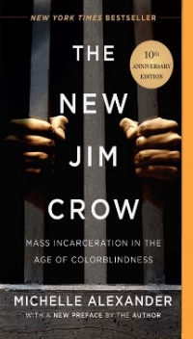
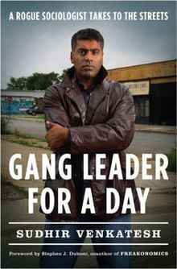
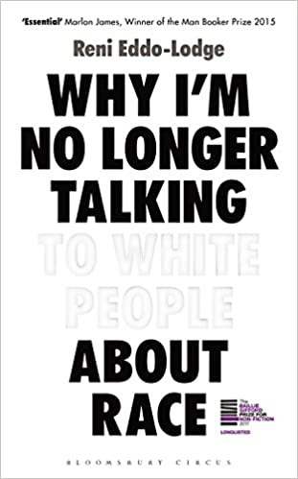

 | www.theguardian.com/education/sociology  www.nytimes.com/topic/subject/sociology  www.tutor2u.net/sociology/blog  www.nortonbooks.typepad.com/everydaysociology/  www.soc.washington.edu/news | www.sociologysal.blogspot.com  www.gendersociety.wordpress.com  www.creativesociology.blogspot.com  www.sociologylens.net  www.blogs.lse.ac.uk/impactofsocialsciences/

 | www.anchor.fm/allsociology  www.measureradio.libsyn.com/podcast  www.socialsciencespace.com/author/socialsciencebites | www.thesocialbreakdown.com  www.soundcloud.com/thesociologicalreview  www.bbc.co.uk/programmes/b006qy05  www.anchor.fm/digital-sociology-podcast

 | www.bbc.co.uk/programmes/topics/Sociology_of_culture  Black Mirror  www.channel4.com/programmes/dispatches | Poor Kids: Life on the Breadline (Child Poverty Documentary) | Real Stories  www.ted.com/talks?topics%5B%5D=sociology  BBC Panorama

Getting prepared for A Level Sociology
Stationary
- Three large folders
- Plastic wallets
- Dividers for each folder
- Different coloured pens for different tasks
- Highlighters
- Hole punched refill pad to keep in your folder
Text books
Try to shop around for these to get them cheaper, if you know a current year 13 student- ask if they or know anyone selling theirs!
- OCR textbooks
- Revision notes revision guide

