Psychology
2020

Bridging work

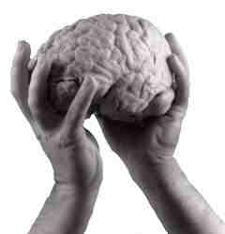
Introduction to A Level Psychology:
Approaches and Research Methods

The aim of Psychology is to explain human behaviour. Such behaviour can be explained from a number of different viewpoints; these are known as ‘approaches’.
The first part of this booklet will introduce you to Psychology and explain how it emerged as a science. The rest of the booklet will guide you through each of the approaches and some research methods.
The three main approaches in Psychology are Behavioural, Biological and Cognitive. Each approach explains the same behaviour in a different way. For example, the Biological approach argues that obesity is due to a biological cause such as genetics, whereas the Behavioural approach suggests that obesity is due to habits we learn from our environment.
The project will require you to read about each approach and complete each task so you have a basic understanding of the 3 approaches before the term starts. Make sure you use the recommended resources to answer the questions and supplement your learning.

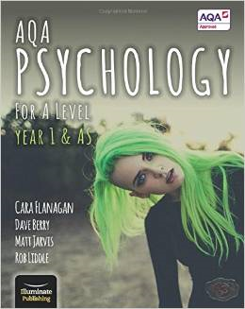
If you would like to purchase a textbook to help with your studies then the class book we will be using is AQA Psychology for A level Year 1 & AS by Flanagan, Berry, Jarvis & Liddle. This is not compulsory as classroom sets will be available, but if you wish to have your own book to use for independent study then please see the link below.
http://www.amazon.co.uk/AQA-Psychology-Level-Year-AS/dp/190868240X/ref=sr_1_1?ie=UTF8&qid=1432029090&sr=8-1&keywords=illuminate+psychology+aqa+year+1

If there are any problems or if you have any questions then contact Miss Ingram gingram@tuxford-ac.org.uk

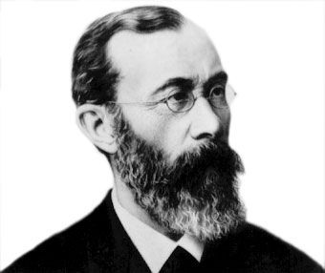
Origins of Psychology

Key term:
Psychology- The scientific study of the human mind and its functions; especially those functions affecting behaviour in a given context.
Wundt
The origin of Psychology as a discipline is widely thought to have occurred in Germany from the work of Wilhelm Wundt. In 1879, Wundt established the first psychology laboratory. He aimed to document and describe the nature of human consciousness.

Wundt used introspection in his work. Introspection is the examination of one’s own thought processes and Wundt’s researchers were trained to examine theirs for feelings, emotions and sensations. This was done in Wundt’s room at the university in a controlled environment. The researchers would then report back what they had experienced and their analysis of that experience. Wundt found that these reports could not be replicated and were therefore unreliable as the experience was too subjective.

The emergence of psychology as a science
By the 20th century the scientific status and value of introspection was being questioned by many. The main problem being that it produced data that was subjective, in that it varied greatly from person to person, so it became very difficult to establish general principles. Watson (1913) brought the language, rigor and methods of the natural sciences into psychology, particularly the use of laboratory experiments. Psychology today is seen as a scientific discipline and, as such, uses a variety of methodologies many of which are empirical (scientific) to investigate human and animal behaviour.

What is meant by the term introspection?

Briefly explain the emergence of psychology as a science

Biological Approach
The Biological approach suggests that the cause of behaviour is due to our biology or physiology. To understand human behaviour, biological psychologists look at genetics, chemical changes, brain structure and evolution.
Genetics:
- Psychologists are interested in whether behavioural characteristics such as intelligence or personality can be inherited in the same way as physical characteristics such as eye colour.
- Research investigating genetics often examines the genes and behaviour of twins.
- Identical twins are 100% genetically similar; the likelihood of them both having a particular behaviour or characteristic is higher than non-identical twins (who share 50% of the same genes).
- If identical twins do show a higher likelihood of sharing a characteristic than non-identical twins then Psychologists argue that there is a genetic explanation.

What is meant by monozygotic?

What is meant by dizygotic?

What is meant by a concordance rate?

Research a particular behaviour or disorder on the internet and find out the concordance rate for this behaviour e.g. schizophrenia, autism, obesity, addiction etc. and explain what the concordance rates mean. Make some notes or print off your research and keep it with your booklet.

Useful sources on genetics:
AQA Psychology for A level Year 1 & AS, Flanagan, Berry, Jarvis & Liddle, page112
http://www.alleydog.com/glossary/definition.php?term=Concordance%20Rate
http://psychcentral.com/encyclopedia/2008/concordance-rate/
http://digest.bps.org.uk/2007/02/why-psychologists-study-twins.html
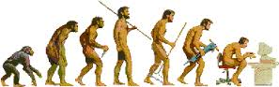
Biological Approach

Evolution:
Charles Darwin argued that over time organisms adapt to their environment through biological evolution. This refers to changes that take place in the characteristics of a population over time. The term natural selection is used to explain this. The main principle behind evolution is that any genetically determined behaviour must enhance survival and as a result continues in future generations. Hence it will be naturally selected.
This occurs naturally where selection occurs because some traits give the individual or species are greater advantage. They are then more likely to survive, reproduce and pass on these traits.
Explain what is meant by evolution

Using an example, explain what is meant by natural selection and how it occurs

Useful sources on evolution:
AQA Psychology for A level Year 1 & AS, Flanagan, Berry, Jarvis & Liddle, page112
http://www.bbc.co.uk/science/humanbody/mind/articles/psychology/psychology_5.shtml
http://natureinstitute.org/pub/ic/ic10/giraffe.htm
http://www.bbc.co.uk/schools/gcsebitesize/science/ocr_gateway_pre_2011/environment/4_survival_of_fittest6.shtml

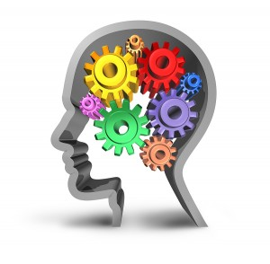
Cognitive Approach
Cognitive Psychologists focus on how people perceive, store, and manipulate information. One of the main assumptions of Cognitive psychology is that information is received by the senses and then processes by various systems in the brain.

The role of schemas:
A schema is a cognitive framework that helps organise and interpret information in the brain. For example we have a schema for a chair- something with legs that we can sit on. This is our schema or package of information that we learn through experience and helps us respond appropriately.
As experiences happen and new information is presented, new schemas are developed and old schemas are changed or modified.
For example, a young child may first develop a schema for a horse. She knows that a horse is large, has hair, four legs and a tail.
When the little girl encounters a cow for the first time, she might initially call it a horse. After all, it fits in with her schema for the characteristics of a horse; it is a large animal that has hair, four legs and a tail. Once she is told that this is a different animal called a cow, she will modify her existing schema for a horse and create a new schema for a cow.
Now, let's imagine that this very young girl encounters a miniature horse for the first time and mistakenly identifies it as a dog. Her parents explain to her that the animal is actually a very small type of horse, so the little girl must this time modify her existing schema for horses. She now realises that while some horses are very large animals, others can be very small. Through her new experiences, her existing schemas are modified and new information is learned.

Read the following sentence and explain the role of schema in helping you make sense of the information
I ma loknig frwrd to strtng psycolgy in sptembr

Cognitive Approach:
Theoretical and computer models:
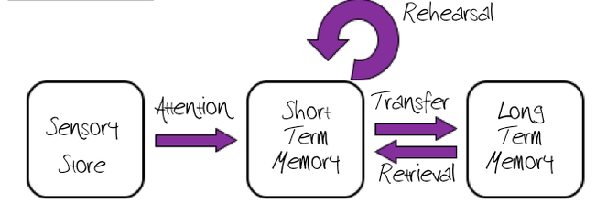
Theoretical models are simplified representations based on current research evidence. Models are often represented in picture form by boxes and arrows which indicate processes. Examples of theoretical models include the multi store model and working memory model, which you will learn about when you study Memory in September. The multi store model is shown below

The cognitive approach also uses computer models where the mind is compared to a computer, known as the computer analogy. This view assumes the brain is similar to a central processing unit. Such computational models have helped establish explanations on artificial intelligence.

These cognitive explanations can be applied to a range of human behaviours. Cognitive psychologists argue that some behaviours or disorders arise due to different (sometimes faulty) ways we process information in the brain. For example an individual with a severe case of amnesia may suffer because of difficulty processing memories. A patient suffering from depression may have distorted or irrational thought processes. All of these are forms of cognitive functions.

Research what is meant by cognitive neuroscience

Useful sources on the cognitive approach
AQA Psychology for A level Year 1 & AS, Flanagan, Berry, Jarvis & Liddle, page110
http://www.simplypsychology.org/cognitive.html
http://www.psychologistworld.com/cognitive/approach.php
http://www.gerardkeegan.co.uk/resource/cognitive.htm
http://bcs.mit.edu/research/cognitiveneuro.html
The Learning approach: Behaviourism

Assumptions
The behaviourist approach is only interested in studying behaviour that can be observed and measured. It is not concerned with investigating mental processes of the mind.
- We learn how to behave from experience.
- Only observable behaviour is measurable scientifically and it is only these behaviours that should be studied.
- It is valid to study the behaviour of animals as they share the same principles of learning.
- We are born a blank slate so there is no genetic influence on behaviour.
- Two key principles: classical and operant conditioning.

Classical conditioning
Classical conditioning is learning through association and was first demonstrated by Ivan Pavlov. Pavlov revealed that dogs could be conditioned to salivate to the sound of a bell if that sound was repeatedly presented at the same time they were given food. Gradually, Pavlov’s dogs learned to associate the sound of the bell with the food and would produce the salivation response every time they heard the sound.
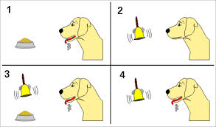

Watch this video on Pavlov’s research: https://www.youtube.com/watch?v=hhqumfpxuzI
What is meant by the term behaviourism?

Outline the main findings of Pavlov’s research

Check your understanding: http://www.nobelprize.org/educational/medicine/pavlov/pavlov.html

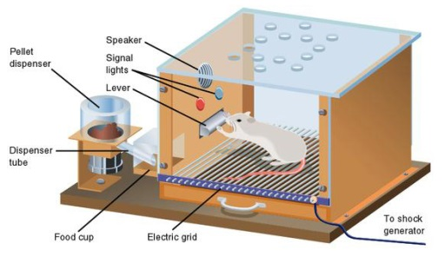
Operant conditioning
BF Skinner (1953) suggested that learning is an active process whereby humans and animals operate on their environment. This is another learning principle of the behaviourist approach and it works on the principle of learning by consequence. There are 3 key ways this can occur.
- Positive reinforcement is receiving a reward when a certain behaviour is performed; for example praise from a teacher for answering a wuestion correctly in class.
- Negative reinforcement occurs when an animal (or human) avoids something unpleasant. For example when a student hands in an essay so as not to be told off, the avoidance of something unpleasant is the negative reinforcement.
- Punishment is an unpleasant consequence of a behaviour, for example being shouted at by the teacher for talking during a lesson.

Positive and negative reinforcement increase the likelihood that behaviour will be repeated. Punishment decreases the likelihood that behaviour will be repeated.

Watch the following videos:
https://www.youtube.com/watch?v=I_ctJqjlrHA (Skinner’s pigeon experiments)
https://www.youtube.com/watch?v=L-DgV2vixSo (Skinner’s box for rats)
https://www.youtube.com/watch?v=QgjUuW_gaBU (project pigeon)

In your own words explain two types of reinforcement

What is the difference between classical and operant conditioning?

Summary task
Using the information you’ve learnt in this booklet so far, complete the summary table below.
Name of approach | Main view/assumption on how behaviour is acquired | Key psychologists in this approach? (where relevant) | Key terms associated with the approach
Biological
Cognitive
Behavioural

Case study
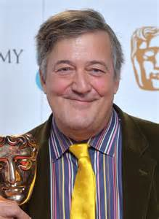
How would you explain the origin of Stephen’s condition using the three approaches you’ve been learning about?
Behavioural explanation:

Cognitive explanation:

Biological explanation:

Check your understanding so far!
Read through the different scenarios and answer the questions using the information you’ve learnt about the 3 main approaches in Psychology. Don’t worry about how many marks the questions are worth, just answer in as much detail as possible and try to include as many key terms as you can.
Scenario 1:
Shortly after eating breakfast with coffee, a traveller is seasick during a ferry crossing. Following this, the smell and taste of coffee always make them feel sick.
Apply what you know about classical conditioning to explain this outcome.
……………………………………………………………………………………………………………………………………………………………………………………………………………………………………………………………………………………………………………………………………………………………………………………………………………………………………………………………………………………………………………………………………………………………………………………………………………………………………………………………………………………………………………………………………………………………………………………………………………………………………………………………………………………………………………………………………………………………………………………………………………………………………………………………………………………………………………………………………………………………………………………………………………………………………………………………………………………………………………………………………………………………………………………

Scenario 2:
Dan and Joe are identical twins. When Dan starts Primary school he starts to show clear signs of aggression towards other children. Joe, however, is not showing any of this type of behaviour. Their father is currently in prison for assault.
Apply your knowledge of the biological approach to explain why the boys’ mum is worried that Joe may also become aggressive.
……………………………………………………………………………………………………………………………………………………………………………………………………………………………………………………………………………………………………………………………………………………………………………………………………………………………………………………………………………………………………………………………………………………………………………………………………………………………………………………………………………………………………………………………………………………………………………………………………………………………………………………………………………………………………………………………………………………………………………………………………………………………………………………………………………………………………………………………………………………………………………………………………………………………………………………………………………………………………………………………………………………………………………………
Research methods
Research Methods is a core part of Psychology as it underpins all of the studies you will learn about over the course. Some of you will be familiar with the main parts of research methods but if you haven’t studied Psychology before some of this may be new to you.
Below is a list of key terms and methods. You need to write a definition for each of the words. Use your previous knowledge and the website below to do this.
https://www.tutor2u.net/psychology/reference/research-methods-key-term-glossary
Key term | Definition
Lab experiment
Field experiment
Natural experiment
Validity
Reliability
Ethics
Covert observation
Overt observation
Questionnaire
Social desirability bias
Structured interview
Unstructured interview
Independent variable
Dependent variable
Extraneous variables
Research/experimental design
Independent groups design
Repeated measures design
Matched pairs design
Opportunity sampling

Random sampling

Volunteer sampling

Systematic sampling

Experiments
This is a key area of research methods in Psychology! You need to read about the studies below and answer the questions underneath.
A researcher want to see if you can get people to perform better with a musical instrument just by raising their expectations. They told musicians in one jazz band that they were playing a piece of music by a well-respected composer. The other jazz band was told that the piece of music they were playing was from someone whose work had been negatively reviewed. They found that people did perform better if they thought they were playing a well-respected piece of work.

- What was the aim of this experiment?

- What was the Independent Variable?

- What was the Dependent Variable?

- What experimental design was used?

- What’s the problem with using that type of experimental design in this study?

Ryback (1969) wanted to research learning in animals. In his experiment, goldfish were trained in a maze shaped like a ‘Y’. Once they’d been trained some were placed in a water solution high in alcohol and some of them keeled over. When the goldfish were retested a week later, those goldfish who hadn’t been exposed to alcohol could remember the maze task but those who blacked out in the alcohol solution had no memory of the task. This demonstrated the severe effects of alcohol on learning.
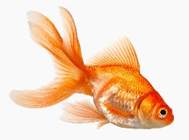

- What is the independent variable in this study?

- What is the dependent variable in this study?

Hypotheses
A hypothesis is a statement of what you believe to be true. A researcher formulates a hypothesis before they carry out their research and where possible this is based on what previous research in the area has found.

There are different types of hypotheses.
Directional: states the difference you expect to find e.g higher or lower, faster or slower, better or worse etc
Example: participants will have higher concentration scores when listening to soft noise than when listening to loud noise.
Non-directional: states that there will be a difference between conditions or groups but not what this difference will be.
Example: There will be a difference in concentration scores depending on whether participants listened to soft music or loud music.
One-tailed: the same as directional.
We can tell which way the cat with one tail is going
Two-tailed: the same as non-directional.

Task: read through the hypotheses below and decide if they are directional or non-directional.
- Boys score differently on aggressiveness tests than girls.
- Students who have a computer at home do better in exams than those who don’t.
- Participants remember words that are early in a list better than words that appear later.
- There is a difference in memory recall scores between those who revise in silence and those who revise with music on.

Task: For the two studies on the previous page write a non-directional hypothesis.
Music experiment:

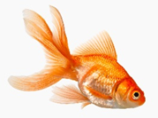
Goldfish experiment:

Experimental designs
This refers to the conditions that the participants will be a part of. There are 3 different types which you will already have researched in the key term task. Using this knowledge have a go at the activity below.

Task: Which of the following is an independent groups design, a repeated measures design and a matched pairs design?
- Depressed patients were assigned to receive either cognitive therapy or behaviour therapy for a 12 week period. A standardised test for depression was administered and participants were paired on the severity of their symptoms.
- A researcher randomly assigned student volunteers to two conditions. Those in condition 1 attempted to recall a list of words that were organised in to meaningful categories; those in condition 2 attempted to recall the same words, randomly grouped on the page.
- A researcher wanted to investigate whether students were more alert in the morning or the afternoon. Each student was given a hazard perception test before school and at the end of the day.

Sampling
Sampling refers to how participants are recruited for a study. In A Level Psychology there are 5 different types of sampling method that you’ll need to know. Complete the task using the information you learnt for the key term table.

Task: Read the scenario and answer the questions below
Two psychology students designed a study on conformity. They planned to ask people to fill in a questionnaire. They arranged it so it looked like some other students had already filled some answers. In fact the student researchers filled in the answers themselves so that most of them were wrong. The student researchers wanted to see if their participants would conform to the wrong answers. They decided to use a random sampling technique.
- Explain how they could obtain a random sample of all the students in their school.
- Explain why they might have found it easier to use an opportunity sample.
- Explain why an opportunity sample might have been less representative.
Extra/ optional tasks
There are lots of podcasts, documentaries, books, lectures and films that are relevant when studying Psychology. Below is a list of examples you could have a look at as some extra preparation for studying Psychology at A Level.
This is not compulsory, but if you choose to read, watch or listen to any of the items below, please write a paragraph on what you have learnt and put this with the rest of the bridging unit work. We’re interested to see what you’ve been interested in!

Reading list:
Memory:
- Before I go to Sleep by S.J. Watson
- Forever today: A memoir of love and amnesia by Deborah Wearing
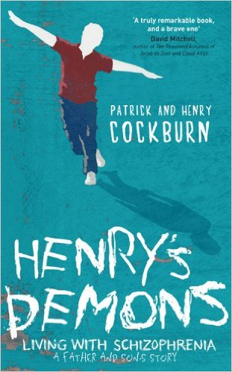
Schizophrenia:
- Shock of the Fall by Nathan Filer
- Henry’s Demons by Henry and Patrick Cockburn
- Surviving Schizophrenia: A memoir by Louise Gillett
- Beautiful Mind by Sylvia Nasar

Mental health:
- Shoot the Damn Dog: A memoir of depression by Sally Brampton
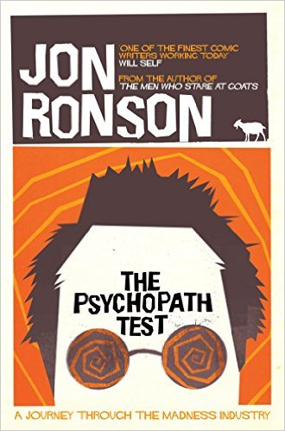
- The Bell Jar by Sylvia Plath
- Prozac Nation by Elizabth Wurtzel
- The man who couldn’t stop by David Adam
- The Psychopath Test by Jon Ronson
- The Wisdom of Psychopaths by Kevin Dutton
- Sybil: The classic true story of a woman possessed by 16 personalities by Flora Schreiber

Misc.
- The Man who mistook his Wife for a Hat by Oliver Sacks
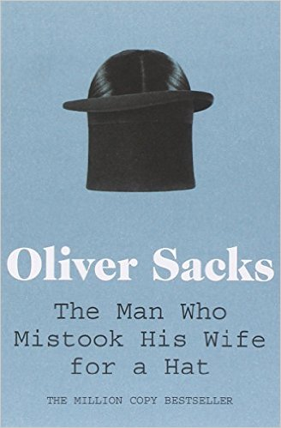
- The Perks of Being a Wallflower by Stephen Chbosky
- The Interpretation of Dreams by Sigmund Freud
- Thinking Fast and Slow by Daniel Kahneman
- Screwed by Ronnie Thompson
- Blank Slate by Stephen Pinker
- Room by Emma Donoghue
- The Skeleton Cupboard by Tanya Byron
- The Selfish Gene by Richard Dawkins
TED talks
These are lectures by experts in their field who discuss many topics in Psychology. They range from a few minutes long to half an hour and there are a lot of different Psychological topics covered.
Simply click on the link below and choose the talks you want to listen to. Don’t forget to write a short summary on what you’ve learnt from each one.

https://www.ted.com/talks?sort=newest&topics%5B%5D=psychology

Films
Below is a selection of films that are relevant to Psychology. Choose the films you want to watch. Don’t forget to write a short summary on what you’ve learnt from each one.
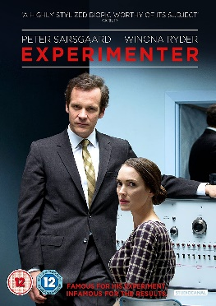
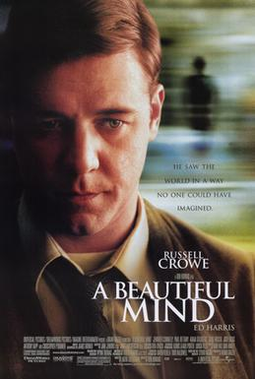
A Dangerous Method
A Beautiful Mind
Good Will Hunting
Mockingbird Don’t Sing
About Time
Shutter Island
Concussion
The Shawshank Redemption
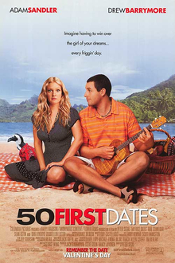
We Need to Talk about Kevin
Experimenter
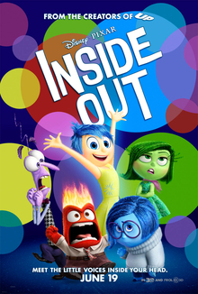
Side Effects
The Adjustment Bureau
50 First dates
The Stanford Prison Experiment
12 Angry Men
Inside out
TV shows/Documentaries/Podcasts
Below is a list of documentaries, podcasts and TV shows that cover a range of topics in Psychology. Choose the programmes you want to watch/listen to. Don’t forget to write a short summary on what you’ve learnt from each one.

- Netflix: Babies
- Netflix: The mind, explained
- The Dark Matter of Love documentary (https://www.dailymotion.com/video/x191s88)
- Body Clock: What makes us tick? https://www.bbc.co.uk/programmes/b0bn5ys4
- OU on the BBC: Eyewitness https://www.open.edu/openlearn/body-mind/ou-on-the-bbc-eyewitness
- American Psychological Association https://www.apa.org/research/action/speaking-of-psychology/
- BBC Radio 4: All in the mind https://www.bbc.co.uk/programmes/b006qxx9/episodes/downloads
- British Psychological Society podcasts https://digest.bps.org.uk/podcast/

If you have any questions or any issues with any of the tasks then please email Miss Ingram (gingram@tuxford-ac.org.uk) and she’ll answer your questions. Hope you’ve enjoyed learning some more about Psychology. We look forward to teaching you the A Level Psychology course soon

