Year 11 Bridging Work:
Government and Politics! 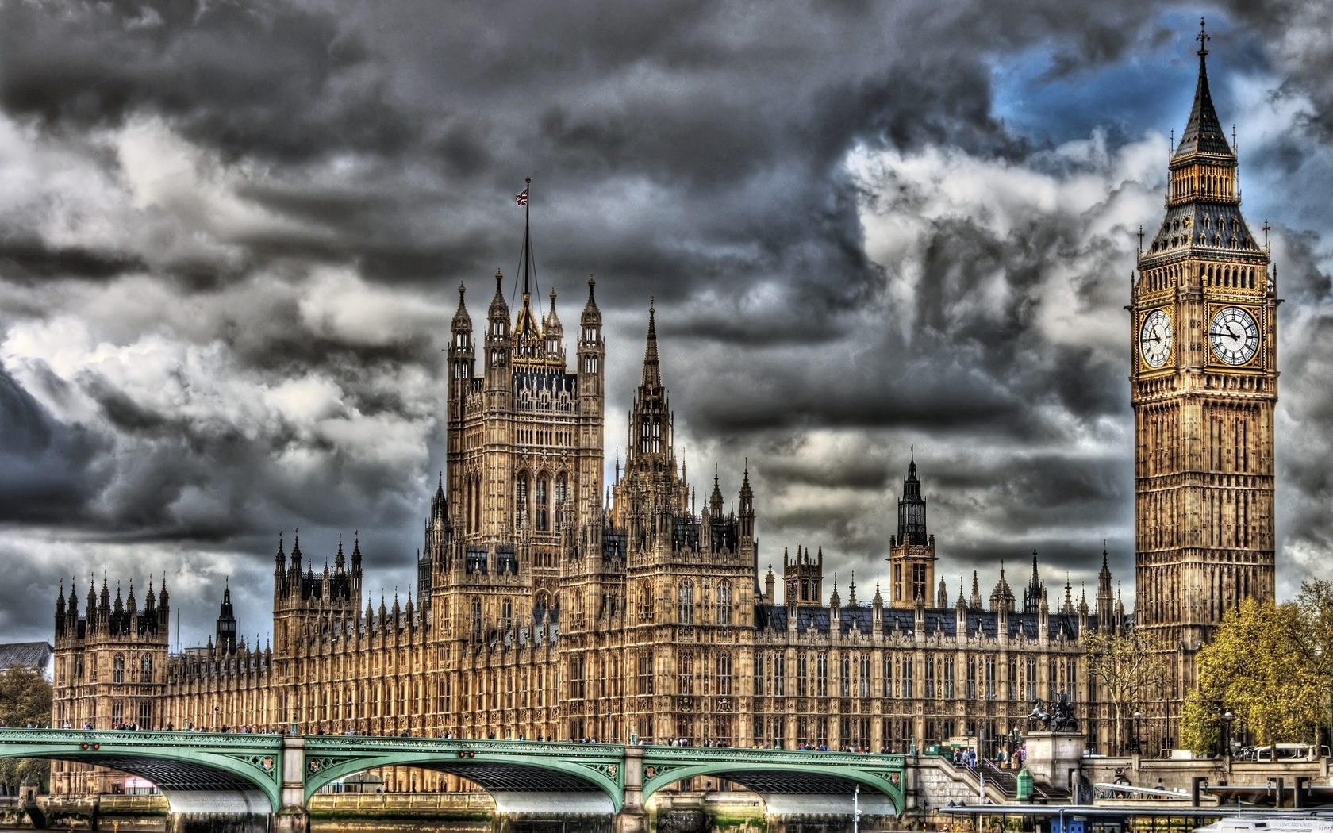
Task 1: Year 11 Bridging Unit: My Member of Parliament (MP)
Go to https://www.theyworkforyou.com/ and look at how your MP has voted. Do you agree with how they voted? Why?
What is your MP’s background like? Is it similar to yours? Do you think your MP should have a similar background to you?
What does your family think of your MP, do they feel represented?
Has your MP had any jobs in the government?
It would say: Minister for…
If so, what are they?
My MP:

Task 2: News scrapbook
Task number 2: Create a scrapbook of news/web articles on British and American Politics. There are no specific subjects as I can’t predict the future, but I’d expect stories on the US election, the corona virus and Labour’s new leader! You can include funny stories too.
If you want to, you could always make the scrapbook on PowerPoint, to save you having to write out lots of information.

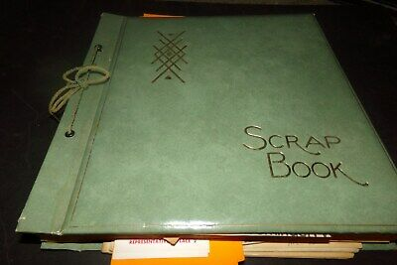

In politics, every example that is in the news is relevant to us, so write them down. Our specific evidence is all in the news! Good stuff ey?!
Task 3: Political leaders!
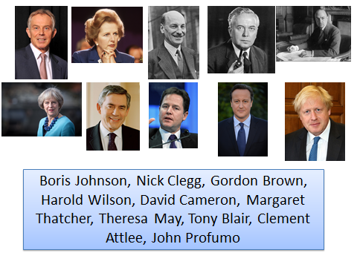
Here are 10 political leaders from the UK (with varying levels of success!) who we will mention in our course. For each of the 10 people, find out:
- Who are they?
- When were they in power? And what position did they hold?
- What are they well known for?
- Is there anything that they have done that you agree with or disagree with? Why?
For Each individual, make a card about them. Try to fill in the information as best you can. It might even be a good idea to ask people at home, what they think of the above!
Task 4: you choose. Pick either of the tasks in the box.
Films/TV/Radio:
Watch/listen to any of the following films/TV/Radio programmes and write a review. Did you like it? Why? What did you learn?
- Andrew Marr’s a History of modern Britain
- Spitting Image: BBC Sitcom
- Yes Minister/Yes Prime Minister: BBC sitcom
- Question Time: BBC
- Any Questions/Any Answers (Radio 4)
- Newsnight
- Panarama Documentaries

Wider Reading (80 marks):
Read one of the following texts and write a 500 word book review on it, did you like it? Why? What did you learn?
- The Establishment by Owen Jones
- An introduction to Political Philosophy, Wolff
- The Blair Years, Alistair Campbell
- Fire and Fury: inside the White house, Wolff.
- The Manifestos for the main political parties.

